Automatic Development Authority

2014

**GROUP 3**

SAMIA SHAFIQUE (1005067)

AHSANUL HADI (1005070)

TAMJID AL RAHAT (1005073)

FAYSAL HOSSAIN SHEZAN(1005076)

SYEDA FARZIA AFROZE(1005082)

Table of Contents

1 OVERVIEW 3

1.1 Introduction: 3

1.2 Project Overview 3

1.2.1 The Land Use Clearance 3

1.2.2 Building Permit 3

1.2.3 Special Project Permit 4

1.2.4 Appeal 4

1.2.5 Complaint 4

1.3 Motivation of the project 4

2 Existing System Study and Scope Analysis 5

2.1 Introduction 5

2.2 Existing system analysis 5

2.3 Problems 6

2.4 Automation status 6

2.5 Scope 7

2.5.1 Portion implementing: 7

2.5.2 Portions not implementing: 9

2.6 Assessment of project’s worthiness 9

2.6.1 Is the system worth implementing 9

2.6.2 Benefits/Contributions of the system 9

2.7 Possible roadblocks of proposed system 10

2.7.1 Problems faced by implementation 10

2.7.2 How to counter them 10

3 Requirement Analysis and Feasibility Study 11

3.1 Introduction 11

3.2 Trends Analysis 11

3.3 Requirement Analysis 11

3.4 Feasibility Study 12

3.4.1 Cultural Feasibility 12

3.4.2 Technical Feasibility 12

3.4.3 Economic Feasibility 13

4 Proposed System Design 14

4.1 Actors 14

4.2 Actor Glossary 15

4.3 Use case diagrams 17

4.4 Data flow diagram 69

4.5 Class and collaboration diagram 71

5 Database Design 85

5.1 Introduction 85

5.2 Overview of the design process 85

5.3 ERD and its Brief Description 85

5.3.1 The ERD at a Glance 86

5.3.2Anatomizing the ERD 88

5.4 Database Schema 94

5.5 Triggers and Procedures 98

5.5.1 Trigger 98

5.5.2 Procedures 99

6 Input and Output Design 100

6.1 Registration UI 100

6.2 User Forms UI 102

6.3 User File Status 103

6.4 User complaint UI 104

6.5 Register officer 105

6.6 Tracer UI 106

6.7 Surveyor UI 108

6.8 Town Planner UI 110

6.9 Authorize Officer UI 112

6.10 Inspector UI 114

6.11 Cheif Inspector UI 115

6.12 Chairman UI 116

7 Project Phase and Activities 117

7.1 Introduction 117

7.2 Work Schedule & Project Time Analysis 117

7.2.1 Activity Network 118

7.2.2 Activity Timeline 119

7.2.3 Pert Chart 120

7.3 Cost Benefit Analysis 121

7.3.1 Development Cost 121

7.3.2 Projected Cash Flow (Yearly) 123

7.3.3 SWOT Analysis 124

7.3.4 Tangible benefit: 124

7.3.5 Intangible benefit: 124

7.4 Risk Analysis & Management 125

7.4.1 Risk & Risk Type 125

7.4.2 Risk Analysis 126

7.4.3 Risk Planning 126

# OVERVIEW

## Introduction:

Technology advanced a great deal in the last decade making management much easier than it previously was. Proper use of technology can lead to an impressive boost in both the private and public sectors. We aim for Bangladesh to be a part of this revolution and thus propose our project – the Automated Development Authority. We refer to RajdhaniUnnayanKatripokkho (RAJUK) as our model throughout this report.

## Project Overview

Our survey concluded that RAJUK has three major sections. The following is a short description of the sections

1. Town Planning - This sector prepares the master plan and area or zonal plans. They use a DAP (detailed area plan) to organize which areas are to be allocated for residential housing, market places, schools, etc. They also make arrangements to constantly improve the current design of Dhaka. Anyone who wishes to put up a building has to go through an elaborate process for a land permit and plan approval.
2. Development Control and Monitoring - This sector controls the development and monitors the approved building plans. When a building is put up the corresponding staff checks that the building is indeed going up as planned. If an unauthorized building is found, steps are taken to demolish it.
3. Undertaking and Execution of Development Projects - This sector deals with the improvement and development of roads, flyovers, bridges, culverts, etc like project HatirJhil, Jhilmil housing project etc.

We hope to automate the first section which directly deals with the majority of the population of Bangladesh.

The main subsystems of our project are briefly described below.

### 1.2.1 The Land Use Clearance

Every land owner of Dhaka has to go through as elaborate process to obtain the permission to use his land. First a form has to be submitted with all the necessary land ownership papers and documents. A file is formed and it goes through document verification, a survey and a DAP verification before a land clearance is issued.

### 1.2.2 Building Permit

After a land clearance is issued the user has to have a Building Permit to legally be allowed to construct a structure at his site. He submits a plan with all the architectural plans and related documents. A file is created and the data is inspected and verified in several stages by inspectors and technical officers to ensure the livability, viability and safety of the building.

### 1.2.3 Special Project Permit

Structures that have a large FAR ratio or encompass a large area are given special attention before a permission is granted to start construction.

### 1.2.4 Appeal

In case a land use clearance, building permit or a special project permit is rejected by RAJUK but the owner feels he has been wronged, then he has the option of filing an appeal to raise his issue at a court.

### 1.2.5 Complaint

Often some people are found to be breaking the law and causing disturbance in the neighborhood. Affected people can file complaint against them through this system.

## Motivation of the project

The population of Dhaka increased from 0.28 million in 1951 to around 1.2 million in 1971. It encompasses a total area of 1528sq km. As the Capital of Bangladesh, Dhaka has now become one of the faster growing cities in the world and its population is likely to exceed 10 million by this time. Although efforts have been made in the past to plan the growth of the City from a district town to one of the largest cities in the world, most have been unsuccessful. As a result, the living conditions have deteriorated very rapidly and the social as well as physical infrastructure are on the verge of collapse. Immediate actions are necessary to bring some discipline to the future growth of the city.

.

# Existing System Study and Scope Analysis

## Introduction

This section analyses the existing system and defines the scope of our project

## Existing system analysis

RAJUK is headed by a Chairman and 5 members. The Chairman is the Chief Executive of the Organization. The operation of RAJUK is as follows:

The five members head the five different departments of RAJUK and are involve in the decision making process. The activities of the above mentioned department are described briefly as follows:

* **Administration and Land**: This department is responsible for overall management and administration assigned by the Chairman and the Board from time to time. Besides it looks after the administrative functions of different sections of the organization including sections dealing with establishment.
* **Planning**: The Planning Department is responsible for the preparation of structural plans, urban area plans and detailed area plans for the greater Dhaka city. They also identify the problems related to urbanization and urban development.
* The Town Planning section provides land use clearance and gives permission for development activities both by private and public sectors. Additionally, they provide permission or rejection of acquisition of lands for development activities.
* The Development Control section deals with the building permits and the special project permits.
* **Development**: This department looks after and implements all sorts of development works/projects of RAJUK regularly assigned by the Government.
* **Finance**: RAJUK’s finance and budget is maintained by this department.
* **Estate**: The Estate wing takes care of the allocation of the residential/commercial/industrial plots/apartments. It is also involved in the completion of lease deeds mutation, transfers to leases, land use clearance and so on.

## Problems

The problems of the current system are as follows:

1. **Inefficient file system** – The whole process makes use of pen and paper managing which can be troublesome. A large amount of space is required to physically store the files of the 1528 sq km under the RAJUK jurisdiction. The office rooms thus become very congested.
2. **Time consuming** - A lot of time is wasted when files are stuck in one place without being forwarded. For example about 30 days is currently required for land clearance but if the time the files spent on a desk waiting to be forwarded, is eliminated then the process could be completed in half the time.
3. **Tedious searching** – file tracking can be quite troublesome. It takes a long time and many steps to find a file. This can be because the officials many not always be present at their desks or they may not remember the name of all the files under them.
4. **Transparency issues** – One part of the office knows very little about another part. Hence it is not visible when and where files are stuck and how each file is handled. This allows room for corruption.
5. **Security issues** – Some files may be misplaced intentionally with unwanted motivations.
6. **Risk of damage** – Files stored physically are subject to damaged by water, fire, etc. It is also possible for the papers to simply tear off from the weak files.

## Automation status

The Plan Preparation Section and the Finance Department is currently automated.

A management information system (MIS) exists but it is not completely developed. Only the name, photo and personal info of clients can be stored so that they can be shown online when their requested query has been processed.

## Scope

### Portion implementing:

We are implementing the subsystems that are directly involved with the citizens and used most frequently. The following show the work flow of these processes:

1. **Land Use Clearance:**
2. **Building Permit:**
3. **Special Project Permit:**
4. **Appeal System:**
5. **Complaint System:**

### Portions not implementing:

We are not implementing the activities of the Estate Department because most of the work of this department is manual or survey dependent and follow various procedures. The citizens involved with this department are mostly not accustomed to the digital world and hence we fear automating it would not be of much use to the public.

We would also skip the Development Department as the projects (like Jhilmil Housing Project, Hatirjhil Project, etc) have major dependencies on the government and many other institutions.

The Detail Area Plan (DAP) production and the Finance Department have already been automated and hence we would not implement these sections either.

## Assessment of project’s worthiness

### Is the system worth implementing

There is no fully functional automated system that RAJUK uses for its Planning Department. Converting the manual system to an automated one has the obvious advantage of faster, less corrupted work.

Bangladesh is a developing country and its people are becoming more and more familiar with technology day by day. This project would assist the citizens in handling their properties smoothly and quickly and also eliminate the vagueness of the whole process.

### Benefits/Contributions of the system

* **Efficient data storage**–The hassle of storing the files physically will be eliminated.
* **Files Management-**Some important data may need fast searching and processing. A big commotion occurs when the office needs to look up past files for reference. Now those files are just a click away.
* **Easy monitoring**– A supervisor can monitor and take steps to further improve efficiency of the system because the status of each file would be clearly visible to him.
* **Faster and efficient office work** – Since data would be presented in a structured way and files would be forwarded online, office work would become swifter.
* **Easier file forwarding**– Now the staff does not have to carry around loads of files from one officer to another. Files can be forwarded online as soon as work of one is completed.
* **Data security** – Physical files may be damaged by water, fire, etc or may be lost due to misuse. However, storing them in a database confirms safety and security. Records of past interactions can also be stored without any difficulty.
* **Complaint system** – There is no solid and effective way of complaint in the current system. Adding this field would make the problems of the citizens more visible and RAJUK can take steps to ensure better quality of life.

## Possible roadblocks of proposed system

### Problems faced by implementation

Computer illiteracy –Some of the office staff may not be very comfortable with using the computer.

Maps/plans/architectural plans - Automating the information of supporting documents (e.g.: architectural plans, maps etc) that are required for the process might be a roadblock for implementing this proposed system.

### How to counter them

Computer illiteracy – A training session can be held to ensure that the technical staff is at ease with this new system.

Automating supporting documents - Architectural plans or other required documents could be provided as a PDF file or scanned directly.

# Requirement Analysis and Feasibility Study

## Introduction

Requirement Analysis and Feasibility Study are one of the most crucial steps in Software Engineering. If the software requirement or demand is not significant then the whole point of designing the software becomes useless. If however the software has the power to meet the demands of the consumers and better the lives of people then it is all worthwhile and the requirement analysis and feasibility study does exactly that, it sorts out the requirements of a software in the community and provides a ground for determining whether the software will be feasible or not, Technically, culturally, operationally and economically. Thus, the requirement analysis and feasibility study provides the platform for designing a demandable software meeting all the requirements of consumers and criterias of feasibility study.

## Trends Analysis

Trend Analysis is the practice of collecting information and attempting to spot a pattern or trend, in the information. Although trend analysis is often used to predict future events, it could be used to predict uncertain events in the past or in other words how certain features of the software could have been designed or built differently. What new features might be added to the software in the future, how this software will change the management system of development authority once introduced are all parts of the Trends analysis.

## Requirement Analysis

The future technology trend of this software might be very broad.

* It might initially be used in desktop computers.
* But might later also be integrated in android phones, iPhones, Blackberry etc.
* And data synchronization within the software between different operating systems and devices might also be integrated as an extra added feature

Requirement Analysis is done based on the following problems faced by different Employees and Client of RAJUK :

**Problems Employee Face**

* Sometimes Employee‘s fail to get correct schedule for their duty.
* Sometimes they get the file of other employees which is a bit harrassing.
* Don't have free access to see the duty roster again and again.
* They have to make lots of report manually.
* Have to keep track of their salaries manually.
* Hard to communicate with clients.

**Problems Client Face**

* They don’t get their file approved on time.
* Sometimes files get lost and client need to submit their documents and file again.

## Feasibility Study

* With the present existing system, the end users find it hard to collect reliable and detailed information about construction of building and the RAJUK board has to manage agencies in a manual way.
* In this proposed system, getting information will be easier. As the new system will be easier to use and manage, the end users and employees can easily adapt to the change.

### Cultural Feasibility

Management supports because:

* Increase end user number
* Controlling the clients will be easier

End user feeling about new system:

* User gets privacy control
* User file will be processed quickly and without much difficulties

### Technical Feasibility

For implementation of the system we will use

* 1. Python – Django Framework for server side implementation
  2. MySQL for Database management
  3. HTML\CSS for web designing
  4. Ajax and Jquery for server connection
  5. And expert engineers will deal with these

### Economic Feasibility

In the existing system following problem were found:

* + No automated file management & process
  + Not user friendly
  + Lack of information
  + Lack of interaction
  + Inefficient file searching

Our system successfully deals with these problems.

# Proposed System Design

## Actors

* Owner
* Bank
* Registry Officer
* Chairman
* Director
* Deputy Town Planner
* Assistant Town Planner
* Tracer
* Surveyor
* DAP officer
* Inspector
* Chief Inspector
* Authorize Officer
* Assistant Authorize Officer
* BC committee member
* Special committee member
* Board member
* LAW
* Complainer
* RAJUK Representative

## Actor Glossary

|  |  |  |
| --- | --- | --- |
| Actor | Short-key | Activity Scope |
| Owner | OWN | Submit various forms ,views results ,submit appeal and complain |
| Tracer | TR | verifies clients documentation ,creates file , traces maps |
| Deputy Town Planner | DTP | issues Land use clearance , forwards file to ATP |
| Assistant Town Planner | ATP | verifies file |
| Surveyor | SRVR | does all the survey work |
| DAP officer | DAPO | checks the file with DAP |
| Inspector | ISP | Inspects land |
| Chief Inspector | CISP | verifies inspectors work |
| Authorize Officer | AO | manages several steps of issuing building permit |
| Assistant Authorize Officer | AAO | checks files for issuing building permit |
| BC committee member | BCCM | checks , analyses and approves building plan in a meeting |
| Special Project committee member | SPCM | checks , analyses and approves special project plan in a weekly meeting |
| Chairman | CHM | Receive and gives decision on appeal application |
| Board member | BM | checks and decides about an appeal in a meeting |
| Director | DIR | Receive files about special project permit  and issues permit to owner |
| Bank | BNK | receives money from owner |
| Registry Officer | RO | creates file and forward it |
| Law Section | LAW | verifies a complain |
| Complainer | COMP | complains to RAJUK about another land owner |

Table: Actor Glossary

## Use case diagrams

Subsystem 1: Form Submission and File Formation

|  |  |  |
| --- | --- | --- |
| Use-case No. / Use-case name | Description | Actor and Role |
| * 1. Submit Form | Filling up and submitting required form with necessary documents and system generates a token. | OWN fills and submits form with necessary documents and system generates a token, RO receives the form. |
| 1.2 Payment Verification | Bank receives payment and the generated token is verified | BNK receives payment and sends token to RO, OWN gives money receipt to RO, RO then verifies token |
| 1.3 File forwarding | A file is created and forwarded to the corresponding section | RO creates and forwards file |



Fig: Use case Diagram of Form Submission and File Formation

Use-case 1.1: Submit Form

|  |  |
| --- | --- |
| Use-case Name | Define Route and Price |
| Use-case ID | 1.1 |
| Priority | High |
| Primary System Actor | OWN |
| External Receiver Actor | RO |
| Description | Filling up and submitting required form with necessary documents |
| Trigger | OWN |

Table: Use-Case Narrative: Submit Form

Typical Course of Events

|  |  |
| --- | --- |
| Actor Action | System Action |
| Step 1 : OWN Fills and Submits form | Step 2 :Generates a token |
| Step 3 : RO receives filled out form |  |

Documentation

* Conclusion: Concludes when Registry Officer receives the form.
* Post-Condition: Inform Owner about the receiving of his/her form.
* Implementation Issues: GUI provided in website for the Owner.

Use-case 1.2: Verify Payment

|  |  |
| --- | --- |
| Use-case Name | Define Route and Price |
| Use-case ID | 1.2 |
| Priority | High |
| Primary System Actor | RO |
| Other Participating Actors | OWN , BNK |
| Description | Bank receives payment. The generated token is verified by RO. RO also receives bank receipt from OWN |
| Trigger | OWN |

Table: Use-Case Narrative: Token Verification

Typical Course of Events

|  |  |
| --- | --- |
| Actor Action | System Action |
| Step 1: OWN pays fee in bank and receives receipt |  |
| Step 2: BNK sends receipt number to RO |  |
| Step 3: RO receives receipt and token no from OWN | Step 4 :Verify receipt number and find the form with corresponding token number |

Documentation

* Conclusion : When Registry Officer verifies the token and receipt number
* Post-Condition: Registry Officer finds the form for corresponding owner.
* Implementation Issues: Token number and receipt number stored in system

Use-case 1.3: File Forwarding

|  |  |
| --- | --- |
| Use-case Name | Define Route and Price |
| Use-case ID | 1.3 |
| Priority | High |
| Primary System Actor | RO |
| Other Participating actor | corresponding section |
| Description | A file is created and forwarded to the corresponding section by RO |
| Trigger | RO |

Table: Use-Case Narrative: File Forwarding

Typical Course of Events

|  |  |
| --- | --- |
| Actor Action | System Action |
| Step 1: RO creates a file and gives it a file number | Step 2 :file saved in Database |
| Step 3 : RO forwards file to corresponding section |  |

Documentation

* Conclusion : Concludes when an actor in corresponding section receives file
* Post-Condition: inform RO that the file has been received
* Implementation Issues: File saved in File records

Subsystem 2: Land Use Clearance

|  |  |  |
| --- | --- | --- |
| Use-case No. / Use-case name | Description | Actor and Role |
| 2.1 File receiving | A file enters the process | RO forwards a file to TR |
| 2.2 Document and land verification | Documents and information of land is verified | TR verifies data and forwards to ATP |
| 2.3 Verify and Forward | Document is verified and the verified document is sent to the SRVR | ATP verify and forward document to SRVR |
| 2.4 Survey | SRVR survey the field and gives file to ATP | SRVR survey and gives file to ATP |
| 2.5 Application correction | A correction of data is requested in case any wrong data is found | OWN is requested to correct any wrong information by ATP |
| 2.6 Forward | ATP forwards the verified documents to DAP | ATP forward file to DAP |
| 2.7 DAP verification | DAP checks if land use is in accordance with DAP | ATP forwards file for DAP checking |
| 2.8 File Forwarding | ATP forwards file to DTP for final checking | ATP forwards file to DTP |
| 2.9 Clearance | An approval is issued and if the approval is approved then DTP sends an approval letter and if it is rejected then DTP sends a rejected letter to OWN | DTP sends a letter to OWN |



Fig: USE-CASE DIAGRAM of Land Use Clearance

Use-case 2.1: File Receiving

|  |  |
| --- | --- |
| Use-case Name | Define Route and Price |
| Use-case ID | 2.1 |
| Priority | High |
| Primary System Actor | RO |
| External Receiver Actor | TR |
| Description | A file enters the process |
| Trigger | RO |

Table: Use-Case Narrative: File Receiving

Typical Course of Events

|  |  |
| --- | --- |
| Actor Action | System Action |
| Step 1 : RO receives a file | Step 2 : Gives file a number |
| Step 3 : RO forwards file to TR | Step 4 : Update file status |

Documentation

* Conclusion : Concludes when TR receive the file
* Post-Condition: inform RO that file has been received
* Implementation Issues: Notify TR about file and file updating

Use-case 2.2: Document and Land Verification

|  |  |
| --- | --- |
| Use-case Name | Define Route and Price |
| Use-case ID | 2.2 |
| Priority | High |
| Primary System Actor | TR |
| External Receiver Actor | ATP |
| Description | Documents and information of land is verified |
| Trigger | TR |

Table: Use-Case Narrative: Document and Land verification

Typical Course of Events

|  |  |
| --- | --- |
| Actor Action | System Action |
| Step 1 : TR verifies files information, land position | Step 2 : Save file in Database |
| Step 3 :ATP receives verified documents | Step 4: Update file status |

Documentation

* Conclusion : Concludes when ATP receive verified file
* Post-Condition: Inform TR about the file
* Implementation Issues: File current status and location updating

Use-case 2.3: Verify and Forward

|  |  |
| --- | --- |
| Use-case Name | Define Route and Price |
| Use-case ID | 2.3 |
| Priority | High |
| Primary System Actor | ATP |
| External Receiver Actor | SRVR |
| Description | Document is verified and the verified document is sent to the SRVR |
| Trigger | ATP |

Table: Use-Case Narrative: Verify and Forward

Typical Course of Events

|  |  |
| --- | --- |
| Actor Action | System Action |
| Step 1 : ATP verifies files | Step 2: Update file information |
| Step 3 : ATP forwards file to SRVR | Step 4: Update file status |

Documentation

* Conclusion : Concludes when SRVR receive verified file
* Post-Condition: Inform ATP about the file
* Implementation Issues: File added to SRVR’s list

Use-case 2.4: Survey

|  |  |
| --- | --- |
| Use-case Name | Define Route and Price |
| Use-case ID | 2.4 |
| Priority | High |
| Primary System Actor | SRVR |
| External Receiver Actor | ATP |
| Description | SRVR survey the field and gives file to ATP |
| Trigger | SRVR |

Table: Use-Case Narrative: Survey

Typical Course of Events

|  |  |
| --- | --- |
| Actor Action | System Action |
| Step 1 : SRVR survey the location and verify information |  |
| Step 2 :ATP receives verified documents | Step 3: Update file status |

Documentation

* Conclusion : Concludes when ATP receive verified file
* Post-Condition: SRVR receives file and get notified
* Implementation Issues: Verification result saved in database

Use-case 2.5: Application Correction

|  |  |
| --- | --- |
| Use-case Name | Define Route and Price |
| Use-case ID | 2.5 |
| Priority | High |
| Primary System Actor | ATP |
| External Receiver Actor | OWN |
| Description | A correction of data is requested in case any wrong data is found |
| Trigger | OWN |

Table: Use-Case Narrative: Application Correction

Typical Course of Events

|  |  |
| --- | --- |
| Actor Action | System Action |
| Step 1 : OWN is requested to submit corrected data if any wrong information is found |  |
| Step 2 :ATP receives and verifies the corrected data | Step 3 : Update database and status of file |

Documentation

* Conclusion : Concludes when ATP receive corrected file
* Post-Condition: Wrong information need to be replaced by right information
* Implementation Issues: Updating database with current status of file

Use-case 2.6: Forward

|  |  |
| --- | --- |
| Use-case Name | Define Route and Price |
| Use-case ID | 2.6 |
| Priority | High |
| Primary System Actor | ATP |
| External Receiver Actor | DAP |
| Description | ATP forwards the verified documents to DAP |
| Trigger | ATP |

Table: Use-Case Narrative: Forward

Typical Course of Events

|  |  |
| --- | --- |
| Actor Action | System Action |
| Step 1 : ATP forwards file to DAP for further investigation | Step 2 :Update file current status |

Documentation

* Conclusion : Concludes when DAP receive file
* Post-Condition: inform ATP that file has been received
* Implementation Issues: File added to DAP’s list

Use-case 2.7: Dap Verification

|  |  |
| --- | --- |
| Use-case Name | Define Route and Price |
| Use-case ID | 2.7 |
| Priority | High |
| Primary System Actor | DAP |
| External Receiver Actor | ATP |
| Description | DAP checks if land use is in accordance with DAP |
| Trigger | DAP |

Table: Use-Case Narrative: DAP Verification

Typical Course of Events

|  |  |
| --- | --- |
| Actor Action | System Action |
| Step 1 : DAP checks if the given information is in accordance with the plan | Step 2 :Update file status |
| Step 3 : Forwards the file to ATP | Step 4 : Update file current status |

Documentation

* Conclusion : Concludes when ATP receive verified file
* Post-Condition: inform DAP that file has been received
* Implementation Issues: Notify ATP about the file

Use-case 2.8: File Forwarding

|  |  |
| --- | --- |
| Use-case Name | Define Route and Price |
| Use-case ID | 2.8 |
| Priority | High |
| Primary System Actor | ATP |
| External Receiver Actor | DTP |
| Description | ATP forwards file to DTP for final checking |
| Trigger | ATP |

Table: Use-Case Narrative: File Forwarding

Typical Course of Events

|  |  |
| --- | --- |
| Actor Action | System Action |
| Step 1 : ATP forward file to DTP | Step 2 :Update file status |

Documentation

* Conclusion : Concludes when DTP receive verified file
* Post-Condition: Inform ATP about the file
* Implementation Issues: File added to DTP’s list

Use-case 2.9: Clearance

|  |  |
| --- | --- |
| Use-case Name | Define Route and Price |
| Use-case ID | 2.9 |
| Priority | High |
| Primary System Actor | DTP |
| External Receiver Actor | OWN |
| Description | An approval is issued and if the approval is approved then DTP sends an approval letter and if it is rejected then DTP sends a rejected letter to OWN |
| Trigger | DTP |

Table: Use-Case Narrative: Clearance

Typical Course of Events

|  |  |
| --- | --- |
| Actor Action | System Action |
| Step 1 : An approval is issued | Step 2 : Update file status |
| Step 3 : Approval or Rejected letter is sent to OWN by DTP | Step 4 : Update the Database and Soft copy is generated and sent to OWN |

Documentation

* Conclusion : Concludes when DTP sends letter to OWN
* Post-Condition: If approved , file is closed , else OWN can appeal against decision
* Implementation Issues: Soft copy and result of the approval is published in the website

Subsystem 3: Building Permit

|  |  |  |
| --- | --- | --- |
| Use-case No. / Use-case name | Description | Actor and Role |
| 3.1 File receiving | A file is received | RO forwards file which TR receives |
| 3.2 Maps verification and documents checking | The information is verified and forwarded | TR verifies the location and documents, file forwarded to ISP |
| 3.3 Field work | The land is inspected physically and data is collected | ISP inspects the land and forwards data to CISP |
| 3.4 Check inspection | Data is rechecked and forwarded | CISP rechecks data and forwards to AAO |
| 3.5 Preliminary Checking | The calculations and building structure is checked | AAO performs a preliminary check and forwards to AO |
| 3.6 Forward to BC committee | Data is checked and forwarded | AO rechecks data and forwards file to BCCM |
| 3.7 Decision making | A decision is made and recorded | A decision is made by BCCM and AO records it |
| 3.8 Permission approval | A permission approval letter is dispatched | AO sends a permission approval letter to OWN |
| 3.9 Permission rejection | A permission rejection letter is dispatched | AO sends a permission rejection letter to OWN |
| 3.10 Application correction | A correction of data is requested in case any wrong data is found | OWN is requested to correct any wrong information by TR, CISP or AO |

## 

Fig: USE-CASE DIAGRAM of Building Permit

Use-case 3.1: File receiving

|  |  |
| --- | --- |
| Use-case Name | Define Route and Price |
| Use-case ID | 3.1 |
| Priority | High |
| Primary System Actor | RO |
| External Receiver Actor | TR |
| Description | A file is received |
| Trigger | RO |

Typical Course of Events

|  |  |
| --- | --- |
| Actor Action | System Action |
| Step 1: RO categorizes a file as a building permit file | Step 2: System forwards the file to TR |
| Step 3: TR receives file | Step 4: An entry is made |

Documentation

* Conclusion : A file is entered for processing in the building permit section
* Post-Condition: TR has access to the new file
* Implementation Issues: The file is maintained by the system and TR receives a notification after the system forwards the file

Use-case 3.2: Maps verification and document checking

|  |  |
| --- | --- |
| Use-case Name | Define Route and Price |
| Use-case ID | 3.2 |
| Priority | High |
| Primary System Actor | TR |
| External Receiver Actor | ISP |
| Description | The information is verified and forwarded |
| Trigger | TR |

Typical Course of Events

|  |  |
| --- | --- |
| Actor Action | System Action |
| Step 1: TR verifies that the maps of the land shown match with the CS, RS and MS | Step 2: The location information is stored in the system |
| Step 3: TR checks that the proper documents are submitted | Step 4: The documents are uploaded |
| Step 5: TR forwards file to ISP | Step 6: System notifies ISP of a new file in his tray |
| Step 7: ISP receives file |  |

Documentation

* Conclusion : Concludes when ISP receives a file with all necessary documents and maps
* Post-Condition: ISP has a file with maps and necessary documents.
* Implementation Issues: The map location and documents information is updated in the system

Use-case 3.3: Field work

|  |  |
| --- | --- |
| Use-case Name | Define Route and Price |
| Use-case ID | 3.3 |
| Priority | High |
| Primary System Actor | ISP |
| External Receiver Actor | CISP |
| Description | The land is inspected physically and data is collected |
| Trigger | ISP |

Typical Course of Events

|  |  |
| --- | --- |
| Actor Action | System Action |
| Step 1: ISP physically inspects the data and collects information on the land | Step 2: The data is forwarded to CISP |
| Step 3: CISP receives file |  |

Documentation

* Conclusion: Concludes when CISP receives information that the ISP collected.
* Post-Condition: Information collected by ISP is forwarded to CISP for verification
* Implementation Issues: Inspection data is stored in a database and forwarded to CISP

Use-case 3.4: Check inspection

|  |  |
| --- | --- |
| Use-case Name | Define Route and Price |
| Use-case ID | 3.4 |
| Priority | High |
| Primary System Actor | CISP |
| External Receiver Actor | AAO |
| Description | Data is rechecked and forwarded |
| Trigger | CISP |

Typical Course of Events

|  |  |
| --- | --- |
| Actor Action | System Action |
| Step 1: CISP checks that the data collected by ISP is valid | Step 2: The data is uploaded in the database and forwarded to AAO |
| Step 3: AAO receives the file |  |

Documentation

* Conclusion : Concludes when AAO receives the inspected file
* Post-Condition: AAO is notified of an inspected file in his tray and he receives it.
* Implementation Issues: The inspection data is updated in the system and forwarded to AAO

Use-case 3.5: Preliminary checking

|  |  |
| --- | --- |
| Use-case Name | Define Route and Price |
| Use-case ID | 3.5 |
| Priority | High |
| Primary System Actor | AAO |
| External Receiver Actor | AO |
| Description | The calculations and building structure is checked |
| Trigger | AAO |

Typical Course of Events

|  |  |
| --- | --- |
| Actor Action | System Action |
| Step 1: AAO checks the technical aspects of the building plan | Step 2: The data collected by the AAO and forwarded to AO |
| Step 3: AO receives the file |  |

Documentation

* Conclusion : Concludes when AO receives a file with a preliminary check
* Post-Condition: AO is notified of a file forwarded by AAO waiting to be authorized
* Implementation Issues: The data collected by AAO is forwarded to AO

Use-case 3.6: Forward to BC committee

|  |  |
| --- | --- |
| Use-case Name | Define Route and Price |
| Use-case ID | 3.6 |
| Priority | High |
| Primary System Actor | AO |
| External Receiver Actor | BCCM |
| Description | Data is checked and forwarded |
| Trigger | AO |

Typical Course of Events

|  |  |
| --- | --- |
| Actor Action | System Action |
| Step 1: AO verifies that the file is properly checked by AAO | Step 2: The data is uploaded in the database and forwarded to BCCM |
| Step 3: BCCM receives the file |  |

Documentation

* Conclusion : Concludes when BCCM receives an authorized file
* Post-Condition: BCCM has an authorized file to discuss in a board meeting
* Implementation Issues: The authorization data is uploaded

Use-case 3.7: Decision making

|  |  |
| --- | --- |
| Use-case Name | Define Route and Price |
| Use-case ID | 3.7 |
| Priority | High |
| Primary System Actor | BCCM |
| External Receiver Actor | AO |
| Description | A decision is made and recorded |
| Trigger | BCCM |

Typical Course of Events

|  |  |
| --- | --- |
| Actor Action | System Action |
| Step 1: a decision is made about the building plan at a committee meeting by BCCM | Step 2: The outcome of the meeting is stored in the system and forwarded to the AO |

Documentation

* Conclusion : Concludes when BCCM has made a decision about the building plan
* Post-Condition: AO is notified of the decision made at the meeting
* Implementation Issues: The outcome of the meeting is entered into the system

Use-case 3.8: Permission approval

|  |  |
| --- | --- |
| Use-case Name | Define Route and Price |
| Use-case ID | 3.8 |
| Priority | High |
| Primary System Actor | AO |
| External Receiver Actor | OWN |
| Description | A permission approval letter is dispatched |
| Trigger | AO |

Typical Course of Events

|  |  |
| --- | --- |
| Actor Action | System Action |
| Step 1:AO updates data about the plan approval in the system and enters a letter to be forwarded to the OWN | Step 2: System notifies OWN of the plan approval and closes the file |

Documentation

* Conclusion : Concludes when OWN receives a plan approval
* Post-Condition: OWN receives a letter stating the plan approval
* Implementation Issues: A GUI interface tells OWN that his plan is approved

Use-case 3.9: Permission rejection

|  |  |
| --- | --- |
| Use-case Name | Define Route and Price |
| Use-case ID | 3.9 |
| Priority | High |
| Primary System Actor | AO |
| External Receiver Actor | OWN |
| Description | A permission rejection letter is dispatched |
| Trigger | AO |

Typical Course of Events

|  |  |
| --- | --- |
| Actor Action | System Action |
| Step 1:AO updates data about the plan approval in the system and enters a rejection letter to be forwarded to OWN | Step 2: System notifies OWN of the plan rejection and closes the file |

Documentation

* Conclusion : Concludes when OWN receives a plan rejection
* Post-Condition: OWN receives a letter stating the plan rejection
* Implementation Issues: A GUI interface tells OWN that his plan is rejected

Use-case 3.10: Application correction

|  |  |
| --- | --- |
| Use-case Name | Define Route and Price |
| Use-case ID | 3.10 |
| Priority | High |
| Primary System Actor | TR, CISP, AO |
| External Receiver Actor | OWN |
| Description | A correction of data is requested in case any wrong data is found |
| Trigger | TR, CISP, AO |

Typical Course of Events

|  |  |
| --- | --- |
| Actor Action | System Action |
| Step 1 : TR, CISP or AO inform OWN about wrong information |  |
| Step 2:OWN provides any necessary corrections | Step 3: System notifies one of TR, CISP or AO of the correction depending on the nature of the correction |

Documentation

* Conclusion : Concludes when TR, CISP , AO receive corrected document
* Post-Condition: one of TR, CISP or AO receives the correction
* Implementation Issues: OWN enters corrected data in a GUI interface and forwards to related officer

Subsystem 4: Special Project System

|  |  |  |
| --- | --- | --- |
| Use-case No. / Use-case name | Description | Actor and Role |
| 4.1 File receiving | A file is received | RO forwards file which DIR receives |
| 4.2 Forward file | The file is forwarded to the meeting | DIR forwards the project file to SPCM |
| 4.3 Meeting | A decision is made about the project | SPCM makes decision at a meeting and lets DIR know the outcome |
| 4.4 Permission approval | The permission is approved | DIR sends an approving letter to OWN |
| 4.5 Permission rejection | The permission is rejected | DIR sends a rejection letter to OWN |



Fig: Use-case Diagram of Special Project System

Use-case 4.1: File receiving

|  |  |
| --- | --- |
| Use-case Name | Define Route and Price |
| Use-case ID | 4.1 |
| Priority | High |
| Primary System Actor | RO |
| External Receiver Actor | DIR |
| Description | A file is received |
| Trigger by | RO |

Table: Use-Case Narrative: File Receiving

Typical Course of Events

|  |  |
| --- | --- |
| Actor Action | System Action |
| Step 1 : RO forwards a file to DIR |  |
| Step 2 : DIR receives the file |  |

Documentation

* Conclusion: Concludes when Director of board receives a file.
* Post-Condition: Inform Director about the receiving of file.
* Implementation Issues : notify Director about the receiving of file and showing file data

Use-case 4.2: Forward file

|  |  |
| --- | --- |
| Use-case Name | Define Route and Price |
| Use-case ID | 4.2 |
| Priority | High |
| Primary System Actor | DIR |
| External Receiver Actor | SPCM |
| Description | The file is forwarded to the committee members |
| Trigger | DIR |

Table: Use-Case Narrative: Forward file

Typical Course of Events

|  |  |
| --- | --- |
| Actor Action | System Action |
| Step 1: DIR forwards the file | Step 2: A copy of the file is sent to SPCM |
| Step 3: Each SPCM receives a copy of the file |  |

Documentation

* Conclusion: When special committee members receives a copy of the file.
* Post-Condition: Inform Special Committee members about receiving a new file.
* Implementation Issues: notify Special Committee members about the receiving of file and showing file data

Use-case 4.3: Meeting

|  |  |
| --- | --- |
| Use-case Name | Define Route and Price |
| Use-case ID | 4.3 |
| Priority | High |
| Primary System Actor | SPCM |
| External Receiver Actor | DIR |
| Description | SPCM makes decision at a meeting and lets DIR know the outcome |
| Trigger | SPCM |

Table: Use-Case Narrative: Meeting

Typical Course of Events

|  |  |
| --- | --- |
| Actor Action | System Action |
| Step 1: A meeting with SPCM is held to take decision |  |
| Step 2: SPCM notifies DIR about the outcome of the meeting | Step 3: Detail outcome of the meeting is sent to the DIR |
| Step 4: DIR receives the detail outcome of the meeting |  |

Documentation

* Conclusion: Concludes when Director of Board receives details outcome of the meeting.
* Post-Condition: inform director about the meeting and its outcome.
* Implementation Issues: Records of outcome of the meeting is saved in system database.

Use-case 4.4: Permission Approval

|  |  |
| --- | --- |
| Use-case Name | Define Route and Price |
| Use-case ID | 4.4 |
| Priority | High |
| Primary System Actor | DIR |
| External Receiver Actor | OWN |
| Description | The permission is approved and an approval letter is sent to the Owner |
| Trigger | DIR |

Table: Use-Case Narrative: Approval

Typical Course of Events

|  |  |
| --- | --- |
| Actor Action | System Action |
| Step 1: DIR submits corresponding approval form for special project permit | Step 2: A soft copy of the approval letter is generated and sent to OWN |
|  | Step 3: Owner is informed about the approval letter and a generated approval letter is sent |

Documentation

* Conclusion: Concludes when Owner receives the approval letter.
* Post-Condition: inform owner about the approval
* Implementation Issues: An approval letter is generated and Records are kept in database by the system

Use-case 4.5: Permission Rejection

|  |  |
| --- | --- |
| Use-case Name | Define Route and Price |
| Use-case ID | 4.5 |
| Priority | High |
| Primary System Actor | DIR |
| External Receiver Actor | OWN |
| Description | The permission is rejected and a rejection letter is sent to the Owner |
| Trigger | DIR |

Table: Use-Case Narrative: Rejection

Typical Course of Events

|  |  |
| --- | --- |
| Actor Action | System Action |
| Step 1: DIR submits corresponding rejection form for special project permit | Step 2: A soft copy of the rejection letter is generated and sent to OWN |
|  | Step 3: Owner is informed about the rejection and a generated rejection letter is sent |

Documentation

* Conclusion: Concludes when Owner receives the rejection letter.
* Post-Condition: inform owner about the rejection
* Implementation Issues: An rejection letter is generated and Records are kept in database by the system

Subsystem 5: Appeal System

|  |  |  |
| --- | --- | --- |
| Use-case No. / Use-case name | Description | Actor and Role |
| 5.1 File receiving | A file is received | RO forwards file which CHM receives |
| 5.2 Forward file | The file is forwarded to the board | CHM forwards the project file to BM and notifies RR, OWN |
| 5.3 Board Hearing | A decision is made | BM makes a decision in Board hearing in presence of OWN and RR |
| 5.4 Appeal approval | The appeal is approved | CHM sends an approving letter to OWN |
| 5.5 Appeal rejection | The appeal is rejected | CHM sends a rejection letter to OWN |



Use-case 5.1: File Receiving

|  |  |
| --- | --- |
| Use-case Name | Define Route and Price |
| Use-case ID | 5.1 |
| Priority | High |
| Primary System Actor | CHM |
| External Sender Actor | RO |
| Description | RO forwards file which CHM receives |
| Trigger | RO |

Table: Use-Case Narrative: File Receiving

Typical Course of Events

|  |  |
| --- | --- |
| Actor Action | System Action |
| Step 1: RO sends a file |  |
| Step 2 : CHM receives the file |  |

Documentation

* Conclusion : concludes when CHM receives the file
* Post-Condition: inform RO that the file has been received
* Implementation Issues: File added to CHM’s list of files

Use-case 5.2: Forward File

|  |  |
| --- | --- |
| Use-case Name | Define Route and Price |
| Use-case ID | 5.2 |
| Priority | High |
| Primary System Actor | CHM |
| Other participating Actors | BM , RR , OWN |
| Description | File is checked and forwarded to Board Members.  A notification about board meeting is also sent to RR, OWN. |
| Trigger | CHM |

Table: Use-Case Narrative: Forward File

Typical Course of Events

|  |  |
| --- | --- |
| Actor Action | System Action |
| Step 1 : CHM checks and verifies the appeal |  |
| Step 2: Forwarded to BM | Step 3 : Notification sent to RR, OWN about Board hearing |

Documentation

* Conclusion : Concludes when RR and OWN receives notification
* Post-Condition: Inform CHM that BM has received the file
* Implementation Issues: File added to board meeting list

Use-case 5.3: Board Hearing

|  |  |
| --- | --- |
| Use-case Name | Define Route and Price |
| Use-case ID | 5.3 |
| Priority | High |
| Primary System Actor | BM |
| External Receiver Actor | RR,OWN |
| Description | BM makes a decision in Board hearing in presence of OWN and RR |
| Trigger | BM |

Table: Use-Case Narrative: Board Hearing

Typical Course of Events

|  |  |
| --- | --- |
| Actor Action | System Action |
| Step 1 :Board hearing held | Step 2 : Outcome Recorded in the file |

Documentation

* Conclusion : Concludes when a decision is taken in meeting
* Post-Condition: inform all actors about the outcome
* Implementation Issues: outcome stored in corresponding file

Use-case 5.4: Appeal approval

|  |  |
| --- | --- |
| Use-case Name | Define Route and Price |
| Use-case ID | 5.4 |
| Priority | High |
| Primary System Actor | CHM |
| External Receiver Actor | OWN |
| Description | CHM sends an approving letter to OWN |
| Trigger | CHM |

Table: Use-Case Narrative: Appeal Approval

Typical Course of Events

|  |  |
| --- | --- |
| Actor Action | System Action |
| Step 1: CHM sends Approval letter |  |
| Step 2: Own receives Approval letter |  |

Documentation

* Conclusion : Concludes when OWN receives letter
* Post-Condition: File is closed
* Implementation Issues: result recorded in file

Use-case 5.5: Appeal Rejection

|  |  |
| --- | --- |
| Use-case Name | Define Route and Price |
| Use-case ID | 5.5 |
| Priority | High |
| Primary System Actor | CHM |
| External Receiver Actor | OWN |
| Description | CHM sends an Rejection letter to OWN |
| Trigger | CHM |

Table: Use-Case Narrative: Appeal Rejection

Typical Course of Events

|  |  |
| --- | --- |
| Actor Action | System Action |
| Step 1: CHM sends Rejection letter |  |
| Step 2: Own receives Rejection letter |  |

Documentation

* Conclusion : Concludes when OWN receives letter
* Post-Condition: File is closed
* Implementation Issues: result recorded in file

Subsystem 6: Complaint System

|  |  |  |
| --- | --- | --- |
| Use-case No. / Use-case name | Description | Actor and Role |
| 6.1 Receive complaint | A complaint is received | AO receives a complaint from COMP |
| 6.2 Forward complaint | Complaint is forwarded | AO forwards complaint to ISP |
| 6.2 Complain inspection | The complaint is inspected | ISP inspects complaint |
| 6.3 Opening 2c file | A 2c file is opened | ISP opens 2c file for the complaint and forwards to CISP |
| 6.4 Supervise inspection | The file is rechecked | CISP rechecks file and forwards to AAO |
| 6.5 Technical verification | Technical data is verified | AO and AAO verifies the technical aspects and forwards to LAW |
| 6.6 Decision making | A decision is made about the complaint | LAW makes a decision and lets AO, COMP know the outcome |
| 6.7 Sending notice | A notice conveying the outcome is dispatched | AO sends a notice to the OWN notifying him of the outcome |
| 6.8 Enlist for taking action | The complaint is enlisted for taking action | AO lists a new entry for which an action is taken |



Fig: Use-case Diagram of Complaint System

Use-case 6.1: Receive Complaint

|  |  |
| --- | --- |
| Use-case Name | Define Route and Price |
| Use-case ID | 6.1 |
| Priority | High |
| Primary System Actor | COMP |
| External Receiver Actor | AO |
| Description | A complaint is received by AO |
| Trigger by | COMP |

Typical Course of Events

|  |  |
| --- | --- |
| Actor Action | System Action |
| Step 1 : COMP submits a complaint along with specific data | Step 2: complaint is forwarded to AO |
| Step 3 : AO receives the complaint | Step 4: Complaint is saved in system database |

Documentation

* Conclusion: Concludes when Authorized Officer receives the complaint.
* Post-Condition: Inform Authorized Officer about the receiving of complaint and an entry is made by the system.
* Implementation Issues : notify Authorized Officer about the receiving of complaint and showing corresponding data

Use-case 6.2: Forward complaint

|  |  |
| --- | --- |
| Use-case Name | Define Route and Price |
| Use-case ID | 6.2 |
| Priority | High |
| Primary System Actor | AO |
| External Receiver Actor | ISP |
| Description | The complaint is forwarded to ISP |
| Trigger by | AO |

Typical Course of Events

|  |  |
| --- | --- |
| Actor Action | System Action |
| Step 1: AO forwards the file | Step 2: Complaint and corresponding data are sent to ISP |
| Step 3: ISP receives the complaint |  |

Documentation

* Conclusion: When Inspector receives the complaint and corresponding data.
* Post-Condition: Inform Inspector about receiving a complaint
* Implementation Issues: notify Inspector about the receiving of complaint and showing complaint data

Use-case 6.3: Complaint Inspection

|  |  |
| --- | --- |
| Use-case Name | Define Route and Price |
| Use-case ID | 6.3 |
| Priority | High |
| Primary System Actor | ISP |
| External Receiver Actor |  |
| Description | ISP inspects on the complain |
| Trigger | ISP |

Typical Course of Events

|  |  |
| --- | --- |
| Actor Action | System Action |
| Step 1: ISP inspects the complain data and inputs inspected data | Step 2: inspected data is saved |

Documentation

* Conclusion: Concludes when inspector records data
* Post-condition: An entry for the inspected data is made
* Implementation Issues: Inspected data is recorded in system database

Use-case 6.4: Opening 2c file

|  |  |
| --- | --- |
| Use-case Name | Define Route and Price |
| Use-case ID | 6.4 |
| Priority | High |
| Primary System Actor | ISP |
| External Receiver Actor | CISP |
| Description | ISP opens a 2c file for the complaint and forward it to CISP |
| Trigger by | ISP |

Typical Course of Events

|  |  |
| --- | --- |
| Actor Action | System Action |
| Step 1: ISP opens a 2c file | Step 2: A 2c file is created for corresponding complain |
| Step 3: ISP forwards the 2c file along with other complain data to CISP | Step 4: 2c file is sent to CISP and CISP is notified |
| Step 5: CISP receives 2c file |  |

Documentation

* Conclusion: Concludes when chief inspector receives 2c file
* Post-condition: inform chief inspector about receiving the 2c file
* Implementation Issues: records of the 2c files are maintained by the system

Use-case 6.5: Supervise Inspection

|  |  |
| --- | --- |
| Use-case Name | Define Route and Price |
| Use-case ID | 6.4 |
| Priority | High |
| Primary System Actor | CISP |
| External Receiver Actor | AAO |
| Description | Complaint file and inspected data is rechecked and forwarded to AAO |
| Trigger | CISP |

Typical Course of Events

|  |  |
| --- | --- |
| Actor Action | System Action |
| Step 1: CISP recheck complain file forward to AAO | Step 2: Complain file is forwarded to AAO with inspected data |
| Step 3: AAO receives the complaint file and inspected data |  |

Documentation

* Conclusion: Concludes when Assistant Authorized Officer receives the complaint file along with 2c file
* Post-Condition: inform Assistant Authorized Officer about receiving a complaint file
* Implementation Issues: Assistant Authorized Officer is notified about receiving of the complaint file

Use-case 6.6: Technical Verification

|  |  |
| --- | --- |
| Use-case Name | Define Route and Price |
| Use-case ID | 6.6 |
| Priority | High |
| Primary System Actors | AO,AAO |
| External Receiver Actor | LAW |
| Description | Data is verified from technical aspects by AO and AAO and then forwarded to LAW section |
| Trigger by | AAO |

Typical Course of Events

|  |  |
| --- | --- |
| Actor Action | System Action |
| Step 1: Data is verified by AO and AAO |  |

Documentation

* Conclusion: Concludes when authorized officers verify data

Use-case 6.7: Decision Making

|  |  |
| --- | --- |
| Use-case Name | Define Route and Price |
| Use-case ID | 6.7 |
| Priority | High |
| Primary System Actor | LAW |
| Other Participating Actors | AO,COMP |
| Description | A decision is made about the complaint |
| Trigger | LAW |

Typical Course of Events

|  |  |
| --- | --- |
| Actor Action | System Action |
| Step 1: LAW section makes the decision | Step 2: AO and COMP are notified about the decision |

Documentation

* Conclusion: Concludes when AO and COMP are notified about the decision.
* Post-Condition: inform owner about the rejection
* Implementation Issues: Records of the decision is kept by system database

Use-case 6.8: Sending Notice

|  |  |
| --- | --- |
| Use-case Name | Define Route and Price |
| Use-case ID | 6.8 |
| Priority | High |
| Primary System Actor | AO |
| External Receiver Actor | OWN |
| Description | A notice conveying the outcome is dispatched |
| Trigger | AO |

Typical Course of Events

|  |  |
| --- | --- |
| Actor Action | System Action |
| Step 1: AO gives a notice to OWN | Step 2: system generates a notice and sends it to OWN and other respective office(if necessary) |
| Step 3: OWN is notified and given a notice about the decision made |  |

Documentation

* Conclusion: Concludes when Owner receives the notice
* Post-Condition: inform owner about the notice
* Implementation Issues: generates a notice and keeps record of the notice given

Use-case 6.9: Enlist for taking action

|  |  |
| --- | --- |
| Use-case Name | Define Route and Price |
| Use-case ID | 6.9 |
| Priority | High |
| Primary System Actor | AO |
| External Receiver Actor |  |
| Description | The complaint is enlisted for taking action |
| Trigger | AO |

Typical Course of Events

|  |  |
| --- | --- |
| Actor Action | System Action |
| Step 1: AO enlist the complain for taking necessary action | Step 2: system enlist complain data for the action to be taken |

Documentation

* Conclusion: Concludes when AO enlists the complaint outcome to take action
* Post-Condition: An entry of the complaint is made
* Implementation Issues: list for the action to be taken is maintained by the system

## Data flow diagram

## Class and collaboration diagram

























































# Database Design

## 5.1 Introduction

Database design is one of the most important part where the system data structures are designed and how these are to be represented in a database. The work here depends on whether an existing database is to be reused or a new database is to be created.

## 5.2 Overview of the design process

The first step involves identifying entities. The types of information that are saved in the database are called 'entities'. Everything that needs to be put in a database fits into one of these entities. If the information doesn't fit into these entities, than it is probably not an entity but a property of an entity.

The next step is to determine the relationships between the entities and to determine the cardinality of each relationship. The relationship is the connection between the entities, just like in the real world: what does one entity do with the other, how do they relate to each other? For example teachers take classes; students are related to a class. The cardinality shows how much of one side of the relationship belongs to how much of the other side of the relationship.

## 5.3 ERD and its Brief Description

The Entity Relationship Diagram (ERD) gives a graphical overview of the database. There are several styles and types of ER Diagrams. A much-used notation is the 'crowfeet' notation, where entities are represented as rectangles and the relationships between the entities are represented as lines between the entities. The signs at the end of the lines indicate the type of relationship. The side of the relationship that is mandatory for the other to exist will be indicated through a dash on the line. Not mandatory entities are indicated through a circle. "Many" is indicated through a 'crowfeet'; de relationship-line splits up in three lines.

### 5.3.1 The ERD at a Glance

The ERD of E-School consists of following entities:

1. Letter
2. File
3. Document
4. Notification
5. Land Use File
6. Special Project File
7. Ownership
8. Applicant
9. Building Permit File
10. User
11. Employee
12. Owner
13. Survey
14. Inspection
15. Plot location
16. Complaint File
17. Notice
18. Complaint Form
19. BPA Form
20. Appeal Form
21. SP form
22. Land Surrounding Info
23. Architect
24. Proposed Structure

The full overview of the ERD is given below:

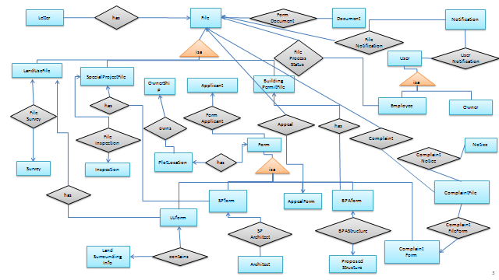

### 5.3.2Anatomizing the ERD

1. Files, Documents and Letters

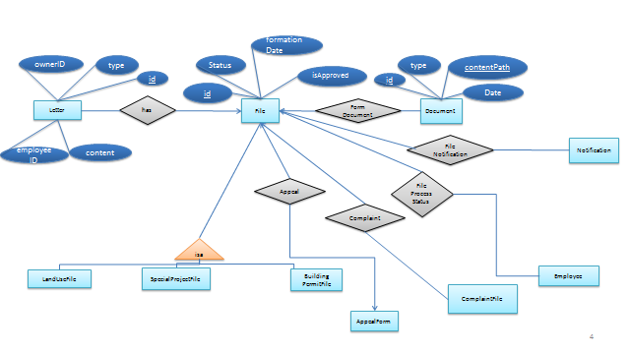

2. File, Employee and Notification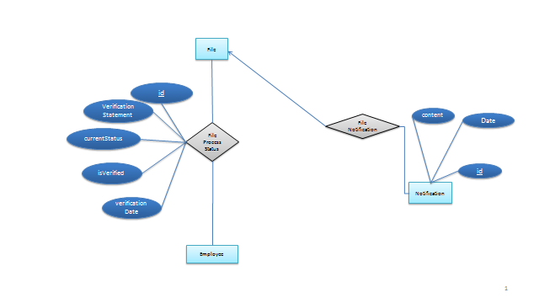3. Land use file, form and survey

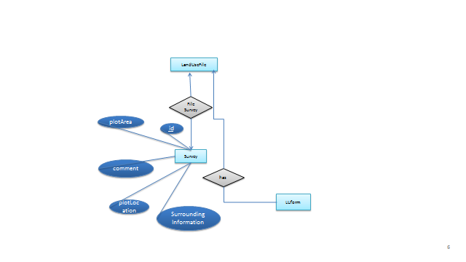

1. Special project form, Inspection, SP Form

### 

1. Complain form, Notice , Complaint File

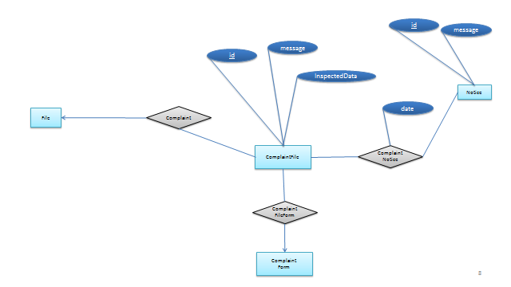

6. Applicant, Plot Location, Form

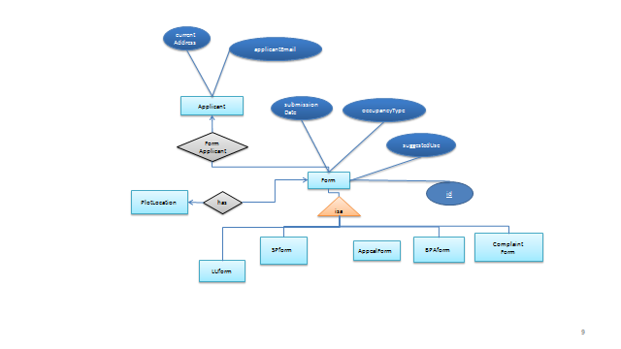7. LU form, Land Surrounding info, land use file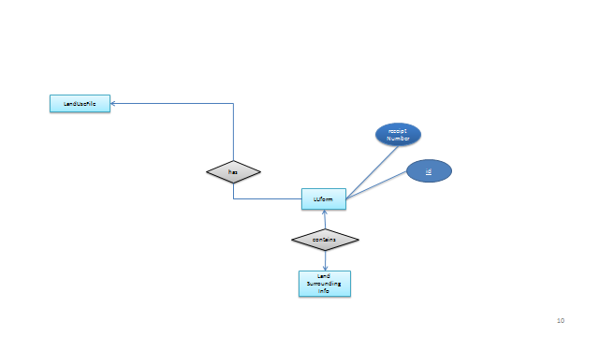

8. Special project file, SP form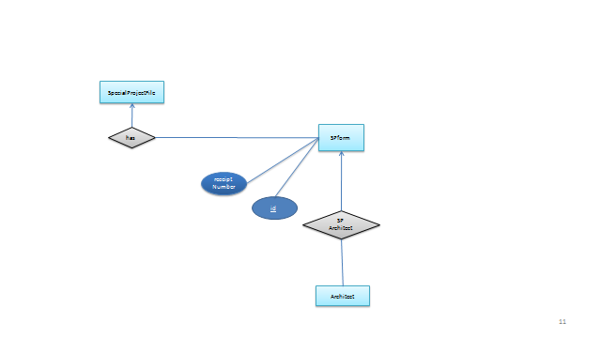9.Building permit, BPA form, Applicant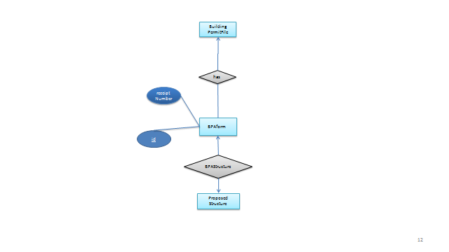

10. User, Employee, Owner 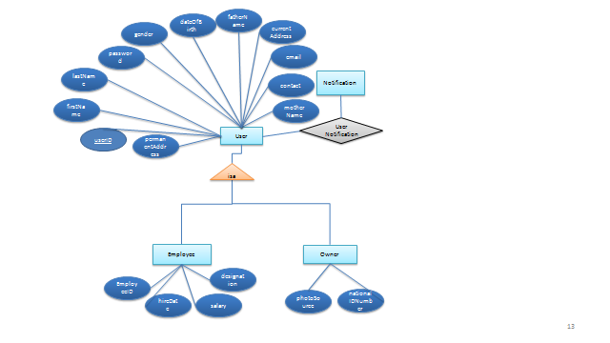11. Plot Ownership, Plot Location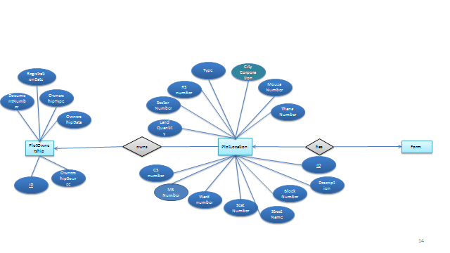

## Database Schema

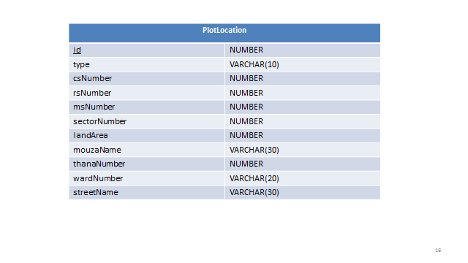

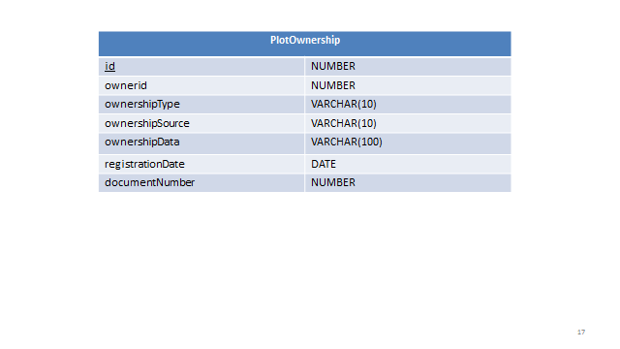

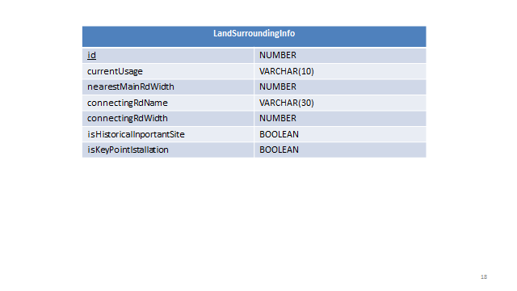

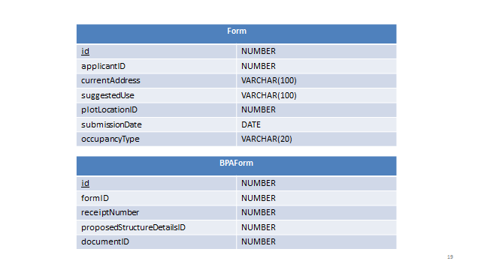

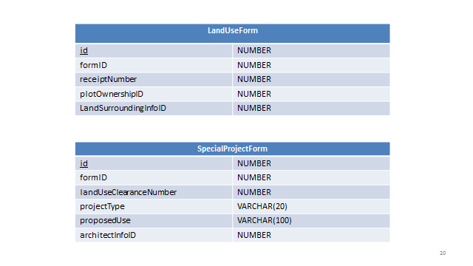

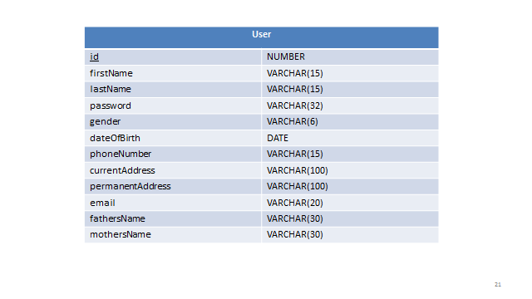

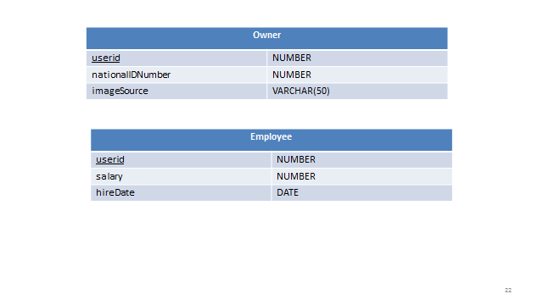

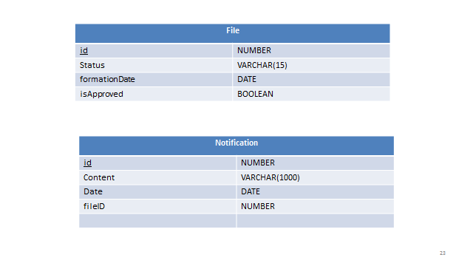

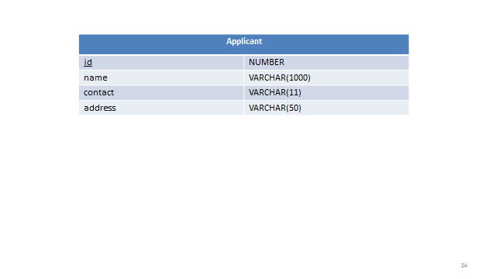

## Triggers and Procedures

### Trigger

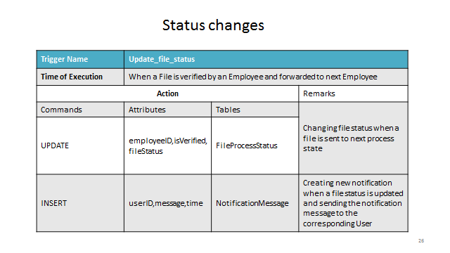

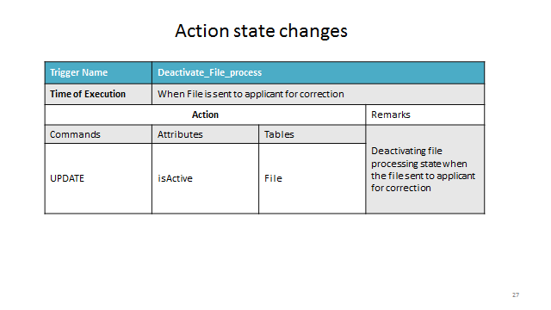

### Procedures

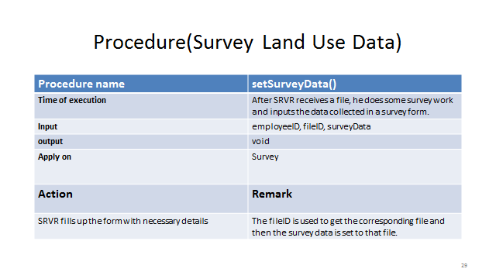

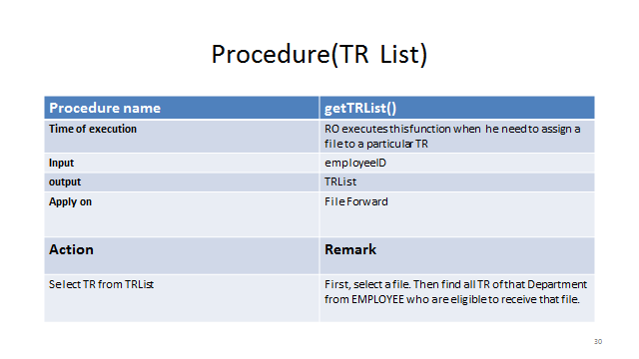

# Input and Output Design

## Registration UI

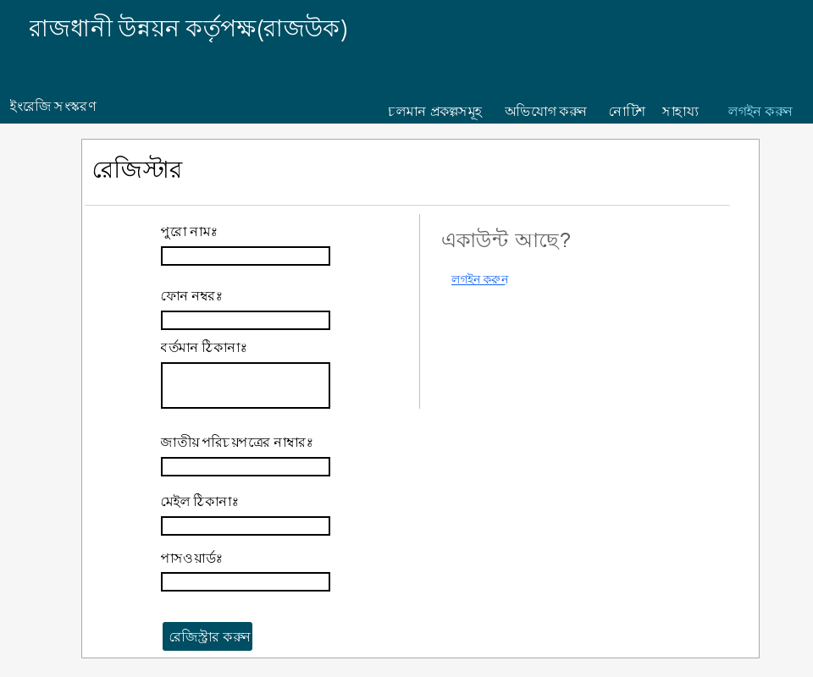

Figure 1Sign Up

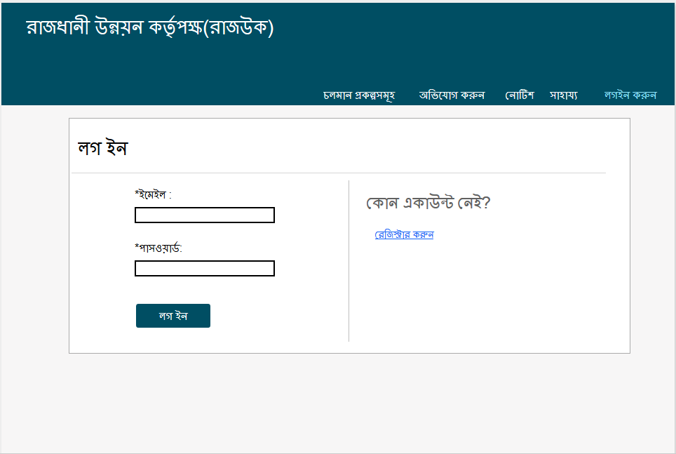

Figure 2SIgnin

## User Forms UI

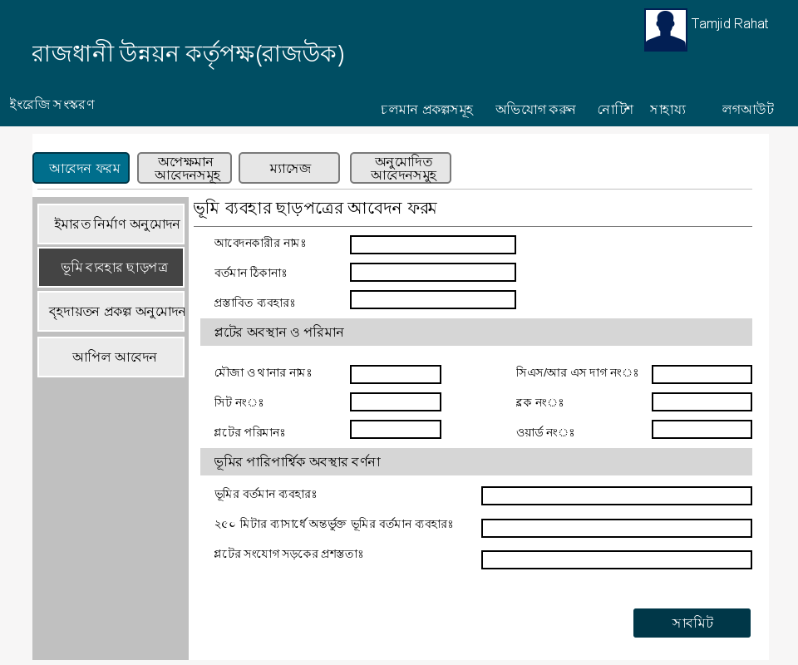

Figure 3 Land Use Clearance Form

## User File Status

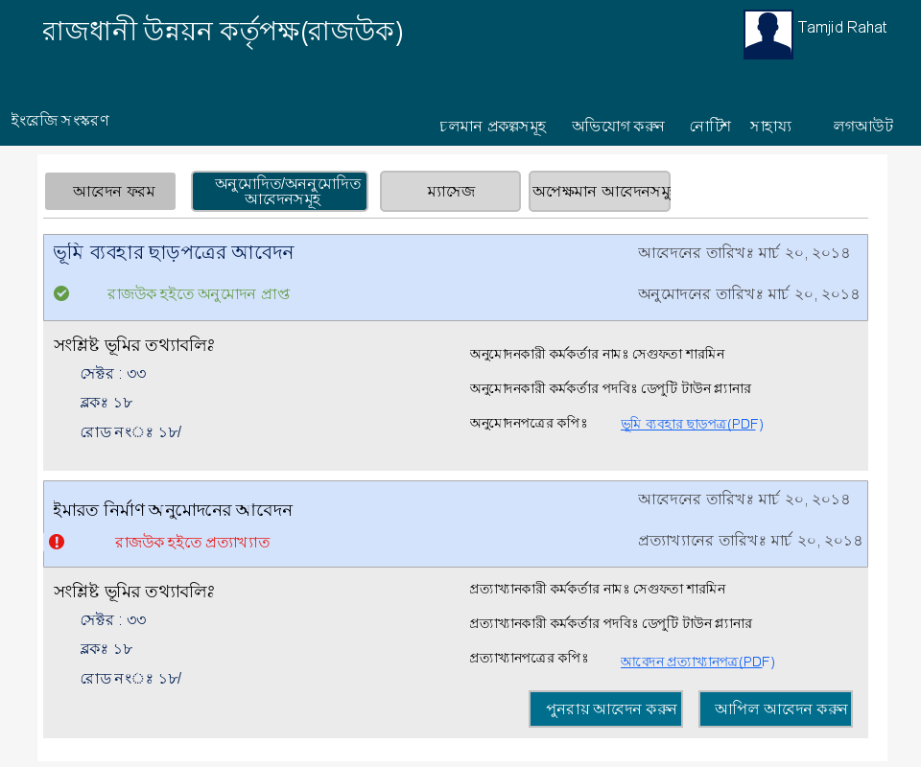

Figure 4 Land Use Clearance Application

## User complaint UI

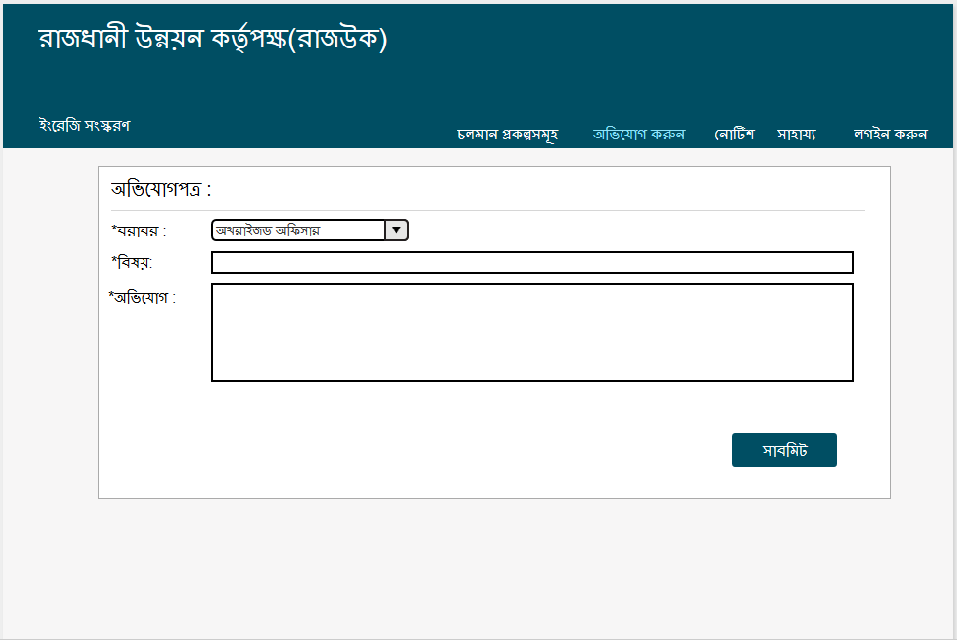

Figure 5 Complaint

## Register officer

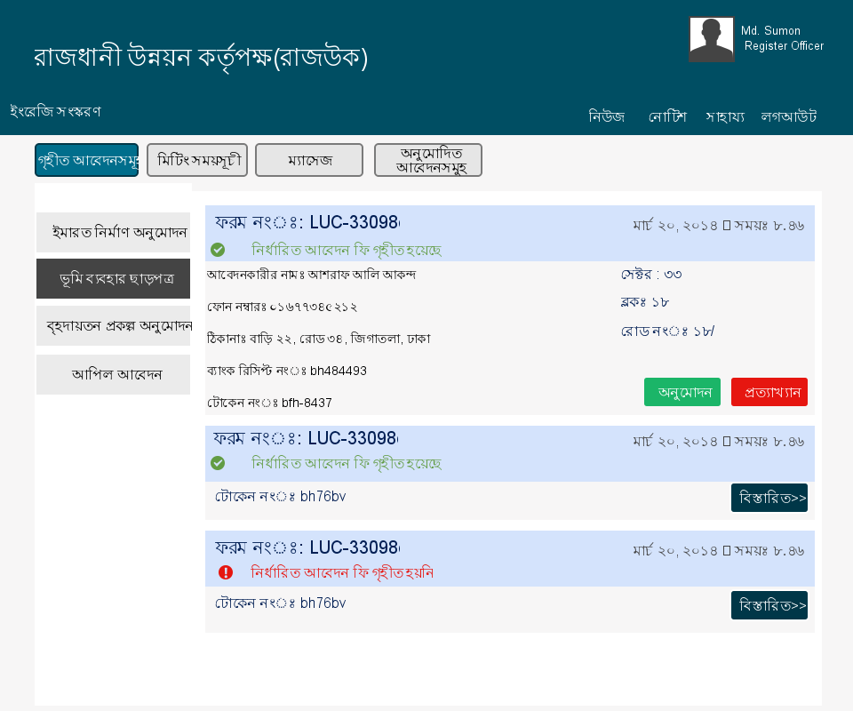

Figure 6 User Interface of Register Officer

## Tracer UI

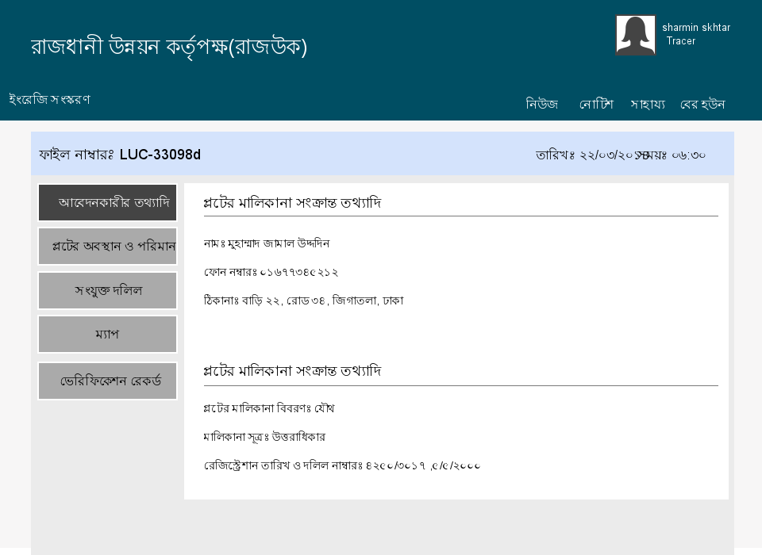

Figure 7 User Interface of Tracer

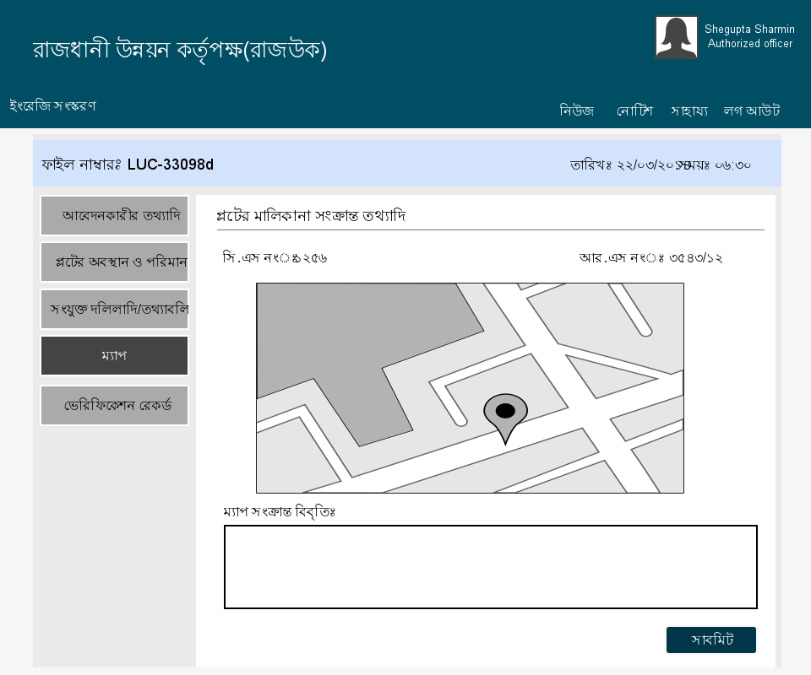

Figure 8 Map view of land

## Surveyor UI

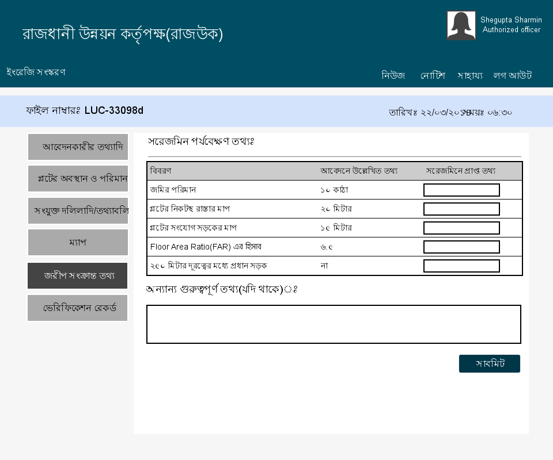

Figure 9 Surveyor Form

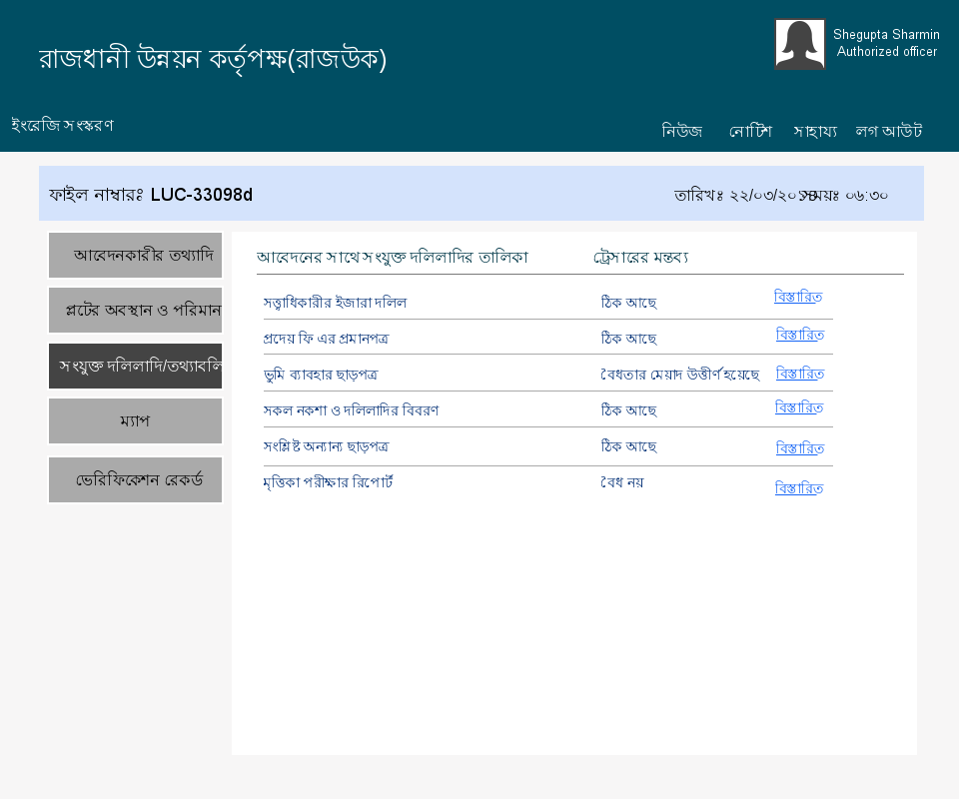

Figure 10 View of Surveyor Data

## Town Planner UI

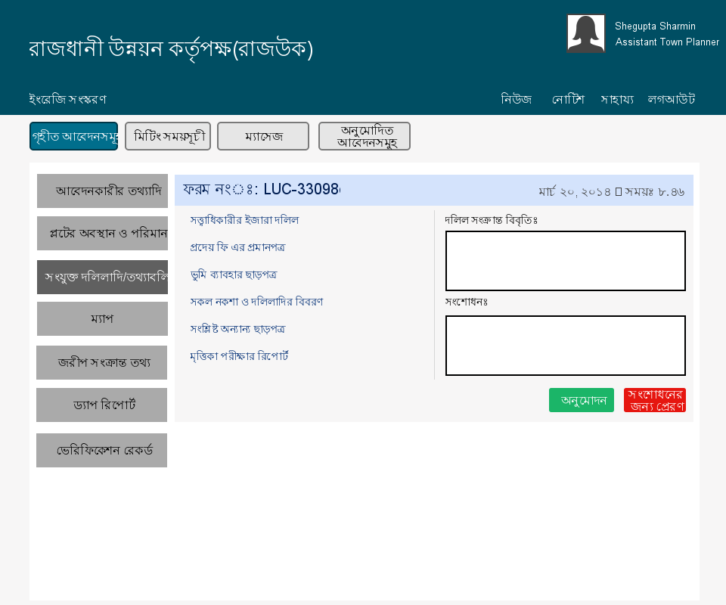

Figure 11 User Interface of Assistant Town Planer

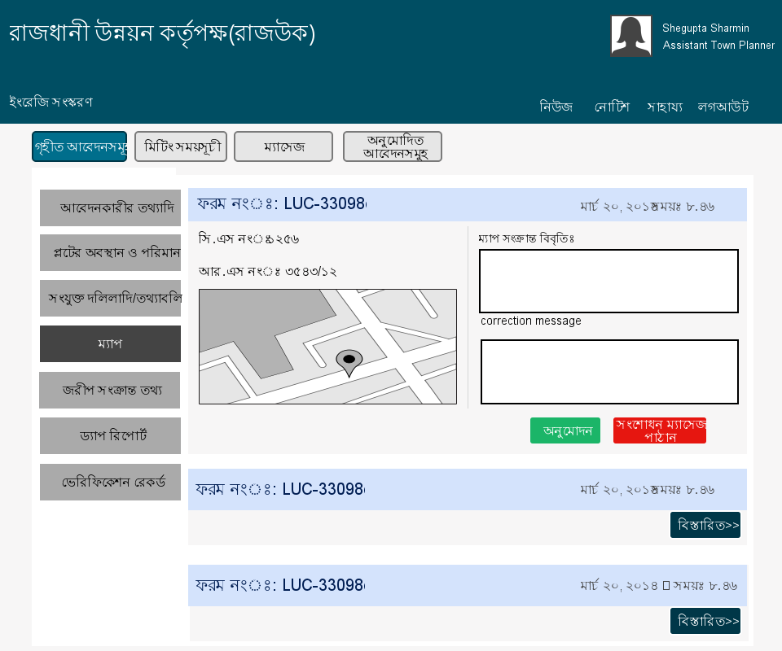

Figure 12 Map view of Land of Assistant Town Planer

## Authorize Officer UI

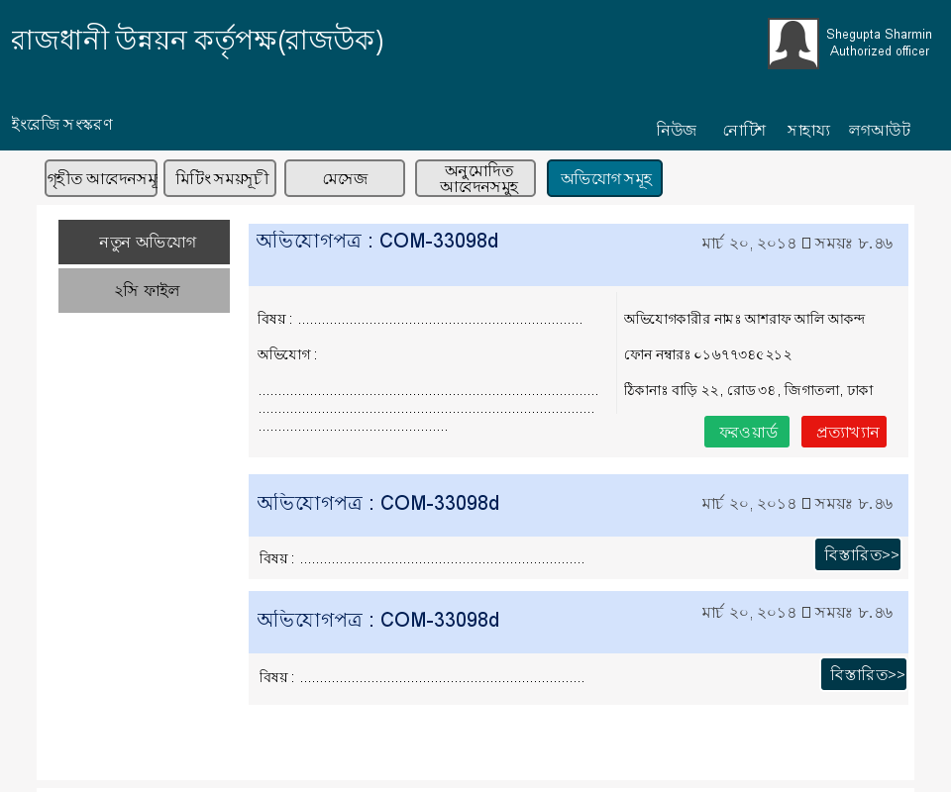

Figure 13 User Interface of Authorize Officer

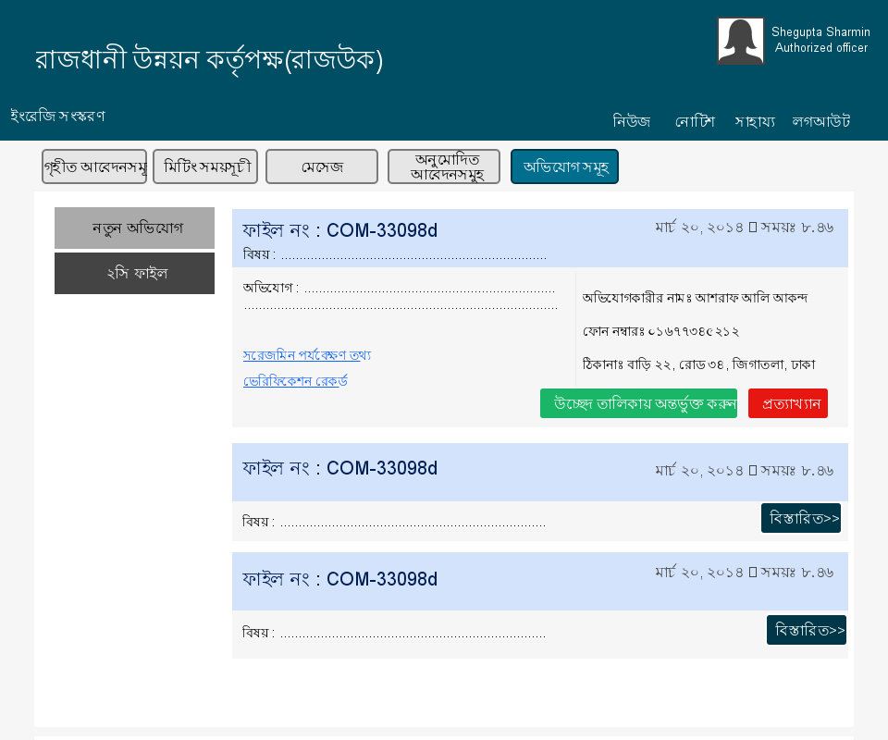

Figure 14 List of Complaints

## Inspector UI

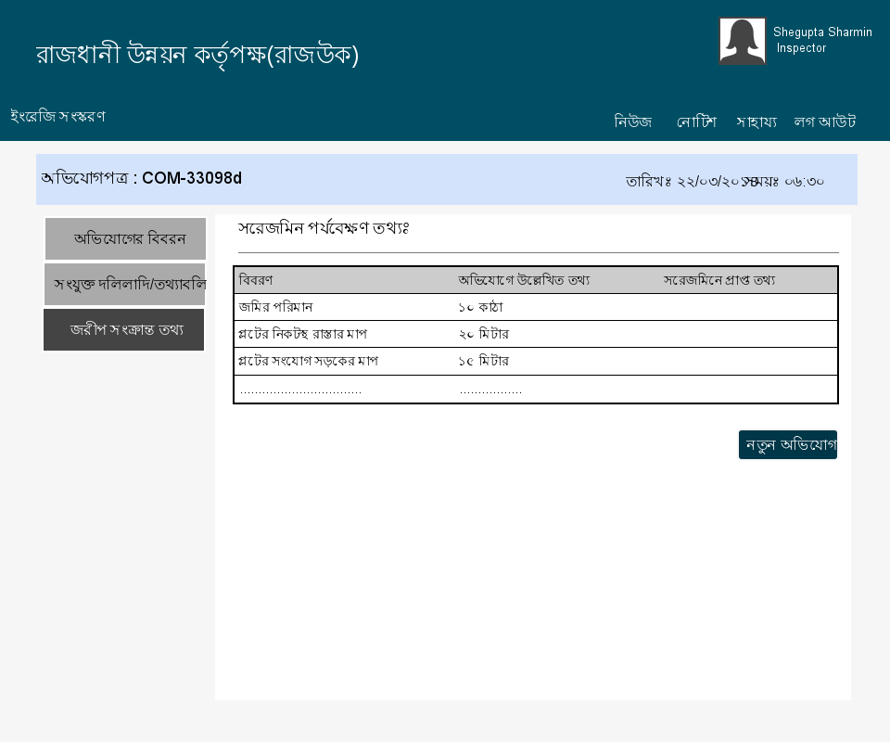

Figure 15 Survey Form of Inspector

## Cheif Inspector UI

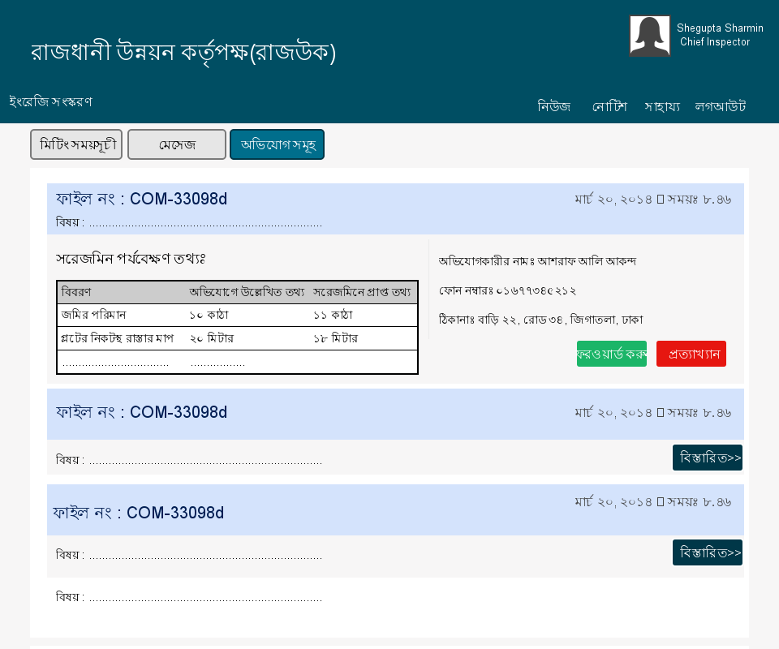

Figure 16 User Interface of Chief Inspector

## Chairman UI

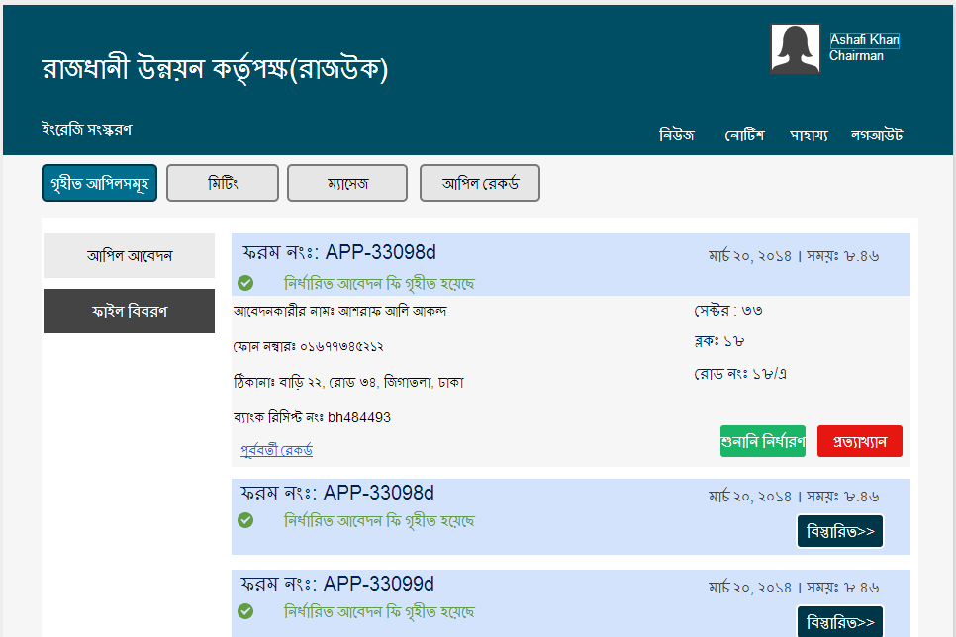

Figure 17 User Interface of Chairman

# Project Phase and Activities

## 7.1 Introduction

Project phase and activity refers to the work schedule, project time analysis, cost analysis and risk analysis. All these analysis are briefly done in this chapter.

## 7.2 Work Schedule & Project Time Analysis

Work scheduling and project time analysis refers to splitting the project into tasks and estimate time and resources required to complete each chart.

Table: Project time analysis

|  |  |  |  |  |
| --- | --- | --- | --- | --- |
| **Tasks** | **Task number** | **Dependency** | **Milestone** | **Estimated working days** |
| **Analyse the current system** | T1 |  |  | 10 |
| **Plan the project** | T2 | T1 | M1 | 11 |
| **List the problems** | T3 | T2 | M2 | 4 |
| **Analyse the problems** | T4 | T3 | M3 | 12 |
| **Identifying business requirement** | T5 |  |  | 6 |
| **Analyse system requirement** | T6 | T2, T5 | M5 | 6 |
| **Design system architecture** | T7 | T6, T4 | M4 | 12 |
| **Design system database** | T8 | T6 | M6 | 10 |
| **Design system interface** | T9 | T6 | M6 | 14 |
| **Design application logic** | T10 | T7, T8, T9 | M7 | 20 |
| **Software instalment** | T11 | T10 | M8 | 15 |

### 7.2.1 Activity Network

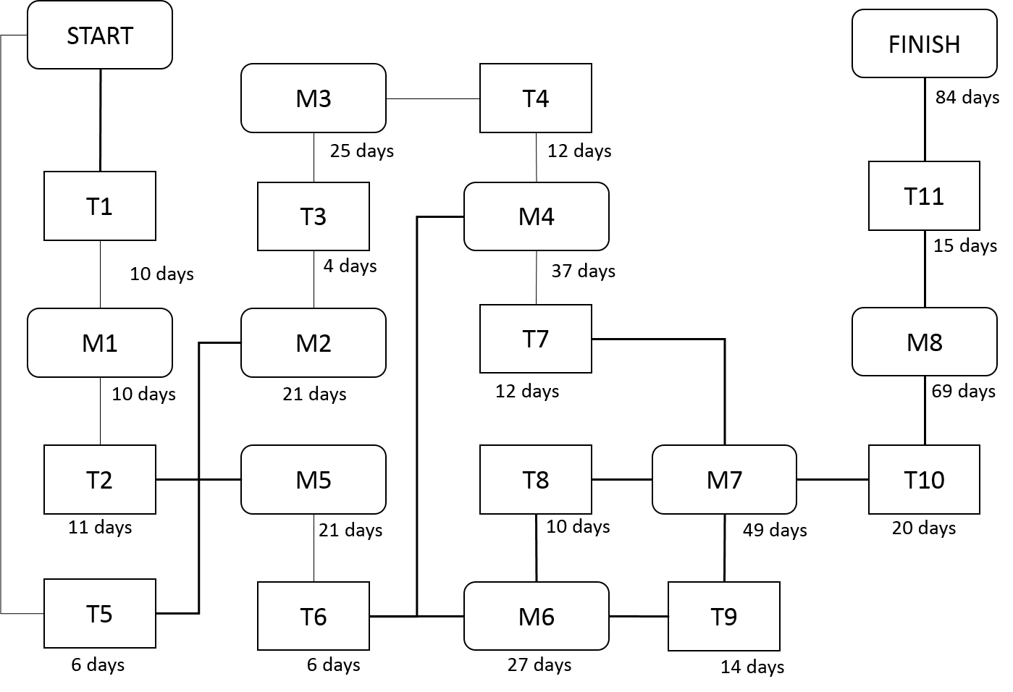

Figure 142: Activity network

### 7.2.2 Activity Timeline

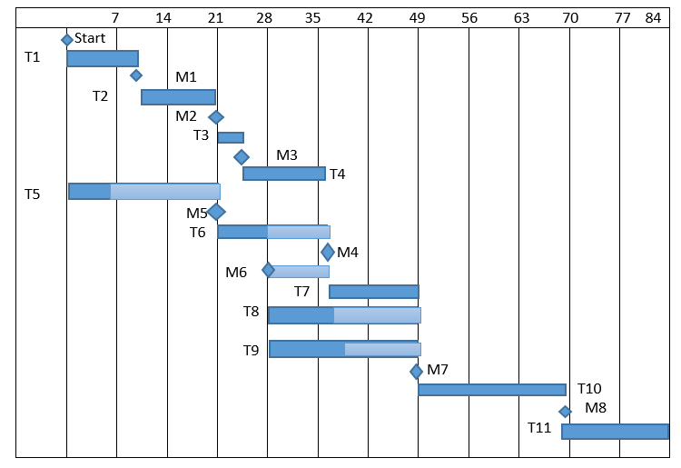

Figure 143: Activity timeline

### 7.2.3 Pert Chart

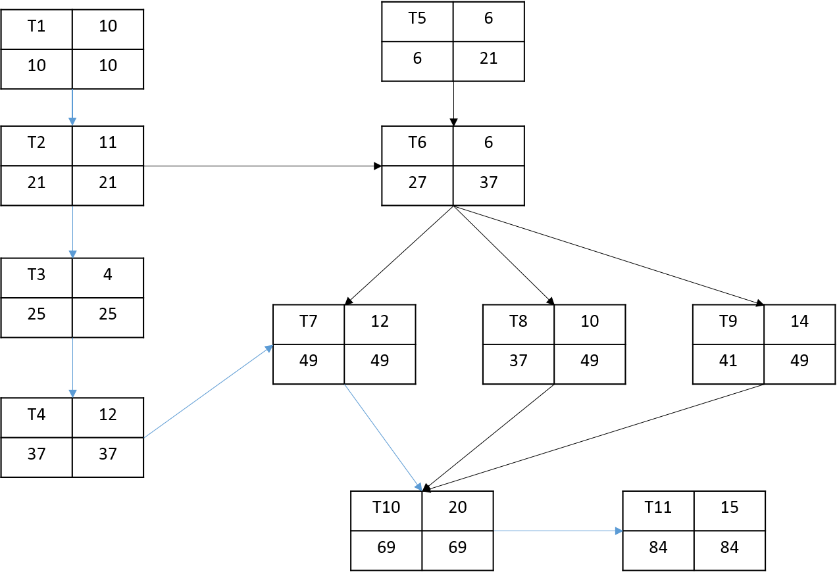

Figure 144: Part chart

## 7.3 Cost Benefit Analysis

The development cost, operational cost, Swot analysis, tangible & intangible cost benefit make up the cost benefit analysis. The previous version of our system was faulty in the sense that the cost benefit analysis reflected the costs and benefits of RAJUK but not those related to the developers. We present the corrected version here in the report.

### 7.3.1 Development Cost

The development costs are portrayed in the table below. The project encompasses a large domain and quite a few employees would be needed to bring it to a complete working condition. Hence some analysts and developers would need to be hired and the corresponding cost is included in the development costs.

|  |  |  |  |
| --- | --- | --- | --- |
| Sector | No of employee | Time period | Costs |
| System analysts (30,000tk/month) | 2 | 6 months | 360000tk |
| Programmer  (50,000tk/month) | 3 | 3 months | 450000tk |
| GUI designer  (20,000tk/month) | 1 | 2 months | 40000tk |
| Database Specialists  (30,000tk/month) | 2 | 4 months | 180000tk |

#### 7.3.1.2 Preliminary costs:

The preliminary costs include the software development cost, the hardware costs, the license costs etc. Since this is a Government related project, it would require significant permissions before it can access the data necessary. A physical survey would also need to be conducted to understand the system better.

|  |  |
| --- | --- |
| **Cost** | **Amount** |
| Software development cost  & Server cost | 8.8 lacs |
| Hardware purchase cost | 11 lacs |
| License Costs | 3.5 lacs |
| Internet Supply Cost | 1 lacs |
| Survey cost | 4 lacs |
| Total cost | 28.3 lacs |

#### 7.3.1.3 Yearly Expenses:

|  |  |
| --- | --- |
| **Cost** | **Amount (yearly)** |
| Software maintenance cost | 3 lacs |
| Hosting cost | 1 lacs |
| Internet cost | 1 lacs |
| Misc | 1 lacs |
| Total cost | 6 lacs |

### 7.3.2 Projected Cash Flow (Yearly)

|  |  |  |  |  |
| --- | --- | --- | --- | --- |
|  | **1st year** | **2nd year** | **3rd year** | **4th year** |
| Total expenses | 34.3 lacs | 6 lacs | 6 lacs | 6 lacs |
| Total revenue | 80 lacs | 1 crore | 1.2 crore | 1.5 crore |
| Profit | 45.7 lacs | 96 lacs | 1.14 crore | 1.46 crore |

### 7.3.3 SWOT Analysis

Table 65: SWOT table

|  |  |
| --- | --- |
| **Strength**   1. **Easier for clients to communicate with RAJUK** 2. **Files organized in a more strategic way** 3. **Important files can be processed quickly without delay** 4. **Transparency leads to a reduction of corruption** 5. **Online application to be used anywhere** | **Weakness**   1. **Some users may not be technically skilled enough to operate the system** 2. **Plot owners, complainers and office staff must have access to the internet** |
| **Opportunities**   1. **Makes the Authority more responsive and interactive** | **Threats**   1. Corruption leads to some files being validated without much processing. If the files do not go through the system then the system would not have any log of it. |

### 7.3.4 Tangible benefit:

* Reduce corruption
* Elimination of brokers and agents
* Less paperwork
* Faster file processing

### 7.3.5 Intangible benefit:

* Transparency
* Better communication between members of this committee
* Better monitoring others work
* Better decision making
* Better service to community

## 7.4 Risk Analysis & Management

Risk management is concerned with identifying risks and drawing up plans to minimize their effect on a project. The steps of risk analysis & management are given below.

### 7.4.1 Risk & Risk Type

Table 66: Risk & risk type

|  |  |
| --- | --- |
| **Risk Type** | **Possible Risks** |
| **Technology** | 1. High Traffic in database 2. Malfunction of server 3. Absence of internet connection in school premises. |
| **People** | 1. Lack of technical expertise in users. |
| **Requirement** | 1. Need of devices with internet connection. |
| **Estimation** | 1. The estimated time for development of the project can cause delay. |

### 7.4.2 Risk Analysis

Table 67: Risk analysis

|  |  |  |
| --- | --- | --- |
| **Risk** | **Probability** | **Effects** |
| **Server malfunction** | Low | Catastrophic |
| **High traffic in database** | Low | Tolerable |
| **Absence of internet connection in school premises.** | High | Serious |
| **Lack of technical expertise in average users** | High | Tolerable |
| **Need of devices with internet connection.** | High | Tolerable |
| **Requirement alteration** | Moderate | Tolerate |

### 7.4.3 Risk Planning

Table 68: Risk planning

|  |  |
| --- | --- |
| **Risk** | **Strategy** |
| **Server malfunction** | Cloud server. |
| **High traffic in database** | Investigate the possibility of buying a higher performance database. |
| **Absence of internet connection in school premises.** | Providing WIFI connection in school premises. |
| **Lack of technical expertise in average users** | Giving training sessions to users in school. |
| **Need of devices with internet connection.** | Using computers of labs and smart phone for this purpose. |
| **Requirement alteration** | Derive traceability information to access requirements change impact. |